CITIZENS INFORMATION SERVICE

Corporate Services Officer

(Full time, Temporary Position)

Applicant Information Pack

October 2026

Corporate Services Officer - Contents

Citizens Information Service Offer- Page 3

CIS Locations - Page 4

Corporate Services Officer Job Description - Page 5

Person Specification - Page 6

Required Competencies – Page 7

Terms and Conditions - Page 8

How to Apply - Page 9

Citizens Information Service - Service Offer

Citizens Information Services (CISs) provide free, impartial and confidential information, advice and advocacy services to the public. Each Citizens Information Service covers a geographical area within their region, facilitating both rural and urban areas, delivering a service through a network of Citizen Information Centres (CICs).

Information and Advice

Our Information Officers assist people with queries in relation to a broad spectrum of public and social services, including social welfare entitlements, income tax calculations, housing supports and access to health services. Our staff receive regular training and social policy updates to ensure that the information and advice that we provide is up-to-date and relevant for CIS service-users.
Social Policy

Our staff also engage in social policy reporting, highlighting issues that affect our clients in accessing public services, which in turn feeds into the work of the Citizens Information Board in the development of policy papers and recommendations to government. Through this process, CIS Information Officers capture social policy issues in real-time, facilitating the development of responsive and evidence-based policy reporting.

Advocacy

When required, Information Officers can provide further support through our advocacy service. This can mean assisting someone to write a letter or make a phone call, or a more complex and longer-term process such as preparing people for, or representing them at, a Social Welfare Appeals Office or Workplace Relations Commission hearing. All Information Officers are supported by a regional Advocacy Support Worker who provides expert advice, coaching and mentoring in this key aspect of our work.

The range and level of advocacy support provided by CISs has continued to develop and expand year on year, with significant outcomes achieved for people around the country in the areas including employment, equality, housing and social welfare.

Citizens Information Services – Locations

Each Citizens Information Regional Company covers a geographical region, facilitating both rural and urban areas, delivering a service through a network of Citizen Information Centres.

The 8 regional CIS companies cover the following areas: North Dublin, Dublin South, North Connacht & Ulster, North Leinster, North Munster, South Connacht, South Leinster and South Munster, as illustrated in the map below. Each CIS Region is subdivided into a number of CIS Service Areas which in turn each contain a number of Citizens Information Centres.

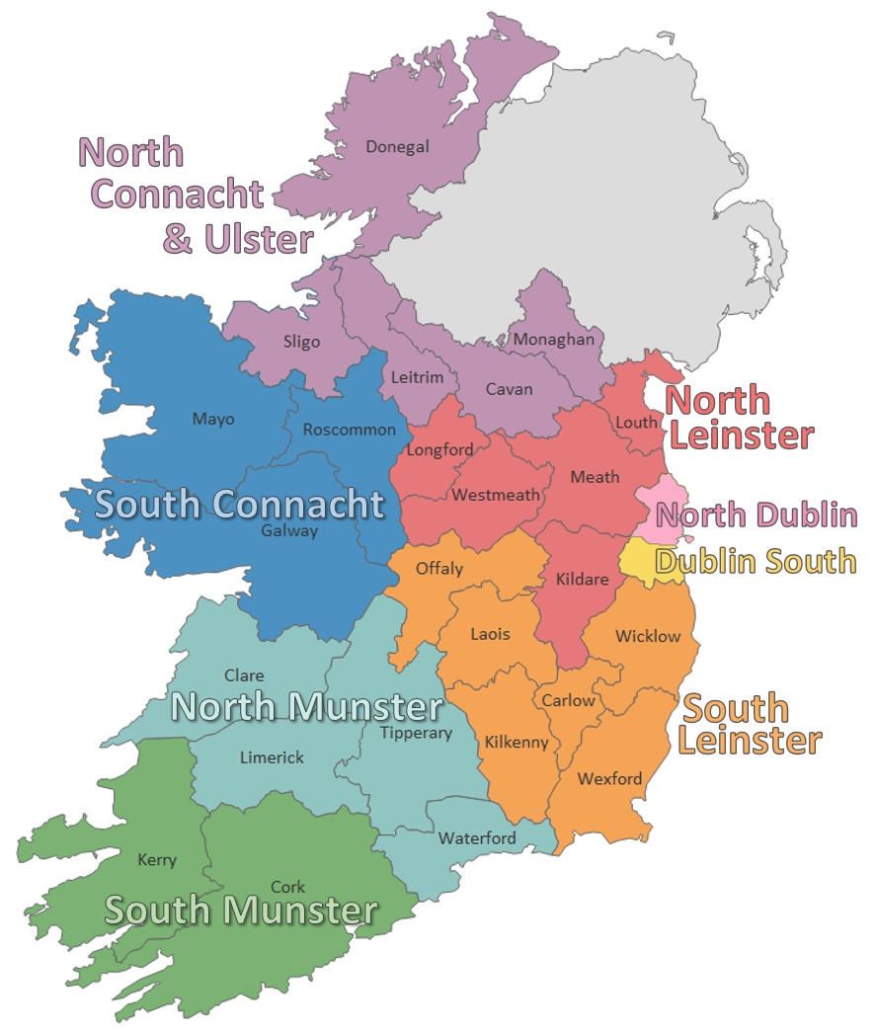

Corporate Services Officer - Job Description

Purpose of the job
The primary role of the Corporate Services Officer is to provide and ensure high-level corporate services support to the CIS Regional Manager and CIS Board. The Corporate Services Officer will directly support the Regional Manager in the work of the CIS and the development of its services, and ensure the enhancement and development of high-quality corporate systems and practices throughout the organisation.

Reporting to
The Regional Manager

Main Duties and Responsibilities

Finance
- Support the Regional Manager in maintaining accurate financial records of all company transactions.
- Maintain records for payroll, bank transactions, and PAYE/PRSI submissions.
- Monitor income and expenditure and assist with budget preparation and oversight.
- Manage bookkeeping tasks, including processing payments and issuing invoices.
- Liaise with creditors, debtors, and financial institutions.
- Ensure, in conjunction with the Regional Manager, financial compliance and record-keeping in line with Citizens Information Board (CIB) financial controls and relevant public sector guidelines.
- Prepare regular financial reports for the Regional Manager and Board of Management.

Procurement
- Support procurement planning for the region, and advise the regional team on best practices, ensuring alignment with public sector procurement guidelines and CIB financial controls.
- Maintain and oversee the regional contracts register, ensuring timely renewals, compliance, and value-for-money assessments.
- Provide procurement reports and insights to the Regional Manager and Board, highlighting compliance status.

Company Governance
- Act as a governance support to the Board, ensuring timely and accurate reporting, and contributing to the development of policies and procedures.
- Provide high-level administrative support to the CIS Board and Sub-Committees.
- Co-ordinate and prepare data for the monthly, quarterly and annual reports.
- Support the Regional Manager with the preparation of reports for submission to the Board of Management, Citizens Information Board and other internal and external stakeholders.
- Prepare and file correspondence on behalf of the Regional Manager and Board of Management.

Human Resources
- Maintain HR records and support recruitment and induction processes.
- Support training coordination and maintain training records.
- Assist with Health & Safety documentation and compliance tracking.
- Liaise with external HR support provider as required.
Office Management
- Provide secretarial and administrative support as required, in compliance with the company’s responsibilities under Data Protection and GDPR requirements.
- Oversee procurement and contract management for office supplies, services, and equipment.
- Implement sustainability initiatives and cost-efficiency measures across regional offices.

Other Responsibilities
- Provide regular, structured updates to the Regional Manager on progress against key operational targets, highlighting risks, achievements, and areas requiring attention.
- Undertake training and development to maintain and improve performance and assist in identifying self-training and support needs.
- In conjunction with the regional management team, act as ICT liaison for the region.
- Represent the region in national working groups or forums as requested by the Regional Manager.
- Attend seminars and meetings when directed by the Regional Manager.
- Other duties as assigned by the Regional Manager, as appropriate to the role.

Corporate Services Officer - Person Specification

Essential Educational Qualifications and Experience
- Administrative qualification QQI Level 6 or similar qualification.
- Experience in financial reporting/bookkeeping.
- Minimum of 3 years' relevant experience in a senior administrative or corporate services role in a medium-sized organisation.

Essential Knowledge, Skills & Experience
- Minimum of 3 years’ experience in financial administration, bookkeeping, and one or more of the areas detailed in the job description above.
- Broad ICT experience, to include high-level skills in all Microsoft programmes and computerised accounts, e.g. SAGE.
- Ability to provide comprehensive secretarial and administrative support to the Regional Manager and Board.
- Very strong organisational and ability to meet agreed work objectives on your own or as part of a team.
- Excellent written, communication and numeracy skills.
- Capacity to operate data storage and retrieval systems for reporting purposes (e.g. HR record management, customer feedback systems, etc.).
- Self-motivated, flexible and reliable.
- Maintenance of the highest standards of honesty and integrity.

Desirable Knowledge, Skills & Experience
- Experience/Knowledge of the Citizens Information Services and/or company governance structures.
- Ability to work in a busy office and to prioritise workload accordingly.

Corporate Services Officer – Required Competencies

Competency | Definition
Secretarial and  Administration | - Demonstrates initiative in improving administrative processes and supporting cross-office coordination.  - Possesses the technical skills for the role, including typing, record keeping, filing, and the inputting and maintenance of data.  - Plans and prioritises effectively to meet targets and deadlines. Identifies what needs to be done and takes responsibility for completing it in a systematic manner.  - Possesses strong ICT skills.  - Ability to handle confidential information with discretion.  - Strong organisational and time management skills.  - Ability to work independently and prioritise tasks effectively.  - Experienced in providing administrative support in a similar office environment.
Financial  Administration | - Ensures the maintenance and development of high-quality financial administrative systems.  - Maintains accurate financial accounts and produces clear and precise financial reports.  - Supports budget planning and financial reporting to inform operational decisions.  - Maintains oversight of financial compliance across multiple functions.  - Uses relevant software efficiently to carry out accounting tasks (e.g. maintaining accounts, processing expenses claims, updating financial records, reports, etc.).
Procurement and Contract Oversight | - Understands procurement guidelines and supports procurement planning.  - Maintains contract registers and ensures timely renewals and compliance.  - Liaises with suppliers to ensure service standards are met.
Information Management | - Understands the need to record and maintain data accurately on behalf of an Organisation.  - Processes and records company information accurately and appropriately.
Company Governance | - Provides administrative support for senior management, including the Board of Management.  - Contributes to the preparation of governance documentation and supports the Board in maintaining compliance with regulatory requirements.  - Supports management to maintain compliance with relevant regulatory bodies, e.g. Companies Registration Office, Charities Regulator
Operational Coordination | - Coordinates activities across finance, HR, governance, and office management to ensure smooth regional operations.  - Identifies areas for improvement and supports implementation of changes.
Communication | - Communicates effectively with internal and external stakeholders, adapting style to suit audience and context.  - Ability to communicate in writing in a clear, concise and professional manner.
Team Working | - Works collaboratively across teams and offices, supporting shared goals and contributing to a positive working environment.  - Demonstrates an openness and receptivity to support, supervision and feedback and adapts approach in a constructive manner.

Corporate Services Officer – Terms and Conditions

This is a temporary position, subject to satisfactory completion of a six-month probationary period. The period of probation may be extended at the discretion of the Regional Manager.

The successful candidate will be available to work 35 hours per week (full time). There may be a requirement to work evenings from time-to-time.

Salary: Scale range of €34,613, €37,028, €38,385, €39,743, €41,102, €43,065, €45,257, €47,079, €48,902 (max), €50,725 (LSI 1) €52,547 (LSI 2). Salaries are pro-rata for part-time staff.

Incremental Credit: It is expected that all new entrants to North Leinster Citizens Information Service will be appointed at point one of the salary scale. However, the company operates an incremental credit process for appointments higher than point one. This process is available to new entrants into Citizens Information Service. Incremental credit criteria, based on the competencies for the role, are assessed against employment history as laid out in the application form only. A request for incremental credit from a successful candidate must be made within the first 3 months of employment. The decision on whether to award an incremental credit or not is a decision made by the Board and is subject to the availability of funding.

Pensio Pension: A company pension scheme is in place, and membership is obligatory upon commencement. Employee contribution; 5% of salary, Employer contribution; 7% of salary. Please note the Citizens Information Service has established a normal retirement age in line with the state pension age (currently 66).

Annual Leave: Calculated on a pro rata basis for part year service as follows:

23 days
24 days after 2 years’ service
25 days after 5 years’ service

Full terms and conditions are contained in a Staff Handbook, which is issued with and forms part of the Employee Contract.

Corporate Services Officer – How to Apply

- A relevant application form can be accessed at www.citizensinformationboard.ie
- Applicants must possess all required competencies for the role and will be shortlisted solely on the basis of information provided in their completed application form.
- Curriculum Vitae (CVs), late, incomplete or hand-written applications will not be considered.
- Closing date: 13:00pm on Tuesday, 27th October 2026
- Please email application form to: recruitment.northleinstercis@citinfo.ie with the subject header: Corporate Services Officer Role
- Please note that shortlisting will apply and canvassing will disqualify.
- If you require any reasonable accommodation to your application due to your circumstances (e.g. disability), please contact the above email address and we will try and facilitate you where reasonably practicable.
- Successful applicants will be required to complete a skills assessment (Word and Excel) on the day of interview.

- Interviews are likely to be held on the week of November 9th, 2026.

- A panel of qualified candidates may be formed from which temporary, full-time Corporate Services Officer posts which arise in a specified period, up to a maximum of 12 months, will be filled. Post applied for will be located in the North Leinster CIS region.

- For information on how your personal data will be used as part of this process please refer to our Data Protection Notice for Job Applicants, available at the following link:
http://www.citizensinformationboard.ie/en/data_protection/cis.html

Citizens Information Services are equal opportunities employers.

