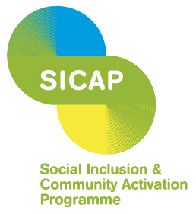

Limerick City Partnership CLG
SICAP Social Inclusion Manager
Limerick City Partnership CLG is an organisation made up of communities, state agencies, social partners, voluntary groups and elected representatives. It works with communities that have benefitted least from economic and social development and aims to promote social inclusion and improve the quality of life of people living in communities in Limerick City.
We are seeking a passionate and experienced Social Inclusion Manager to join our Senior Management Team in a full-time role. This position is central to leading and coordinating the implementation of Limerick City Partnership’s social programmes.
The successful candidate will lead the development and delivery of innovative social inclusion strategies and initiatives across Limerick City, working collaboratively with community groups, partners and local stakeholders to address social exclusion and strengthen community participation. The role will also involve managing programme teams and budgets while ensuring effective programme delivery, quality standards, compliance and strong organisational partnerships.

Contract Type: Permanent contract subject to the completion of a successful probationary period of 6 months. This position is funded by SICAP, and all posts are offered subject to available funding.
Salary: €62,482 - 72,703. Appointment will be made at the first point of that scale.
The person appointed will need: A relevant third-level or professional qualification and/or at least 5 years’ experience in a similar type of role, at a senior level is a minimum requirement.

A full Job Description and Application Form can be downloaded from the Jobs/Vacancies section on https://limerickcitypartnership.ie/work-us

Closing date for receipt of application is 5pm, Friday, 9th October 2026.
Only completed application forms via the advertised link will be accepted. CVs are not accepted.
Shortlisting will apply.
Limerick City Partnership CLG is an equal opportunities employer. Canvassing will disqualify.
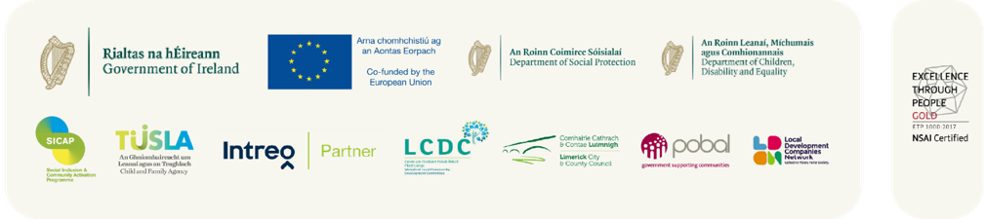
Registered Company Name: Limerick City Area Partnership | Charity number: 20029692 | CRO Number: 167004

The Social Inclusion and Community Activation Programme (SICAP) is co-funded by the Irish Government, through
the Department of Rural and Community Development and the Gaeltacht, and the European Social Fund Plus under
the Employment, Inclusion, Skills and Training (EIST) Programme 2.

