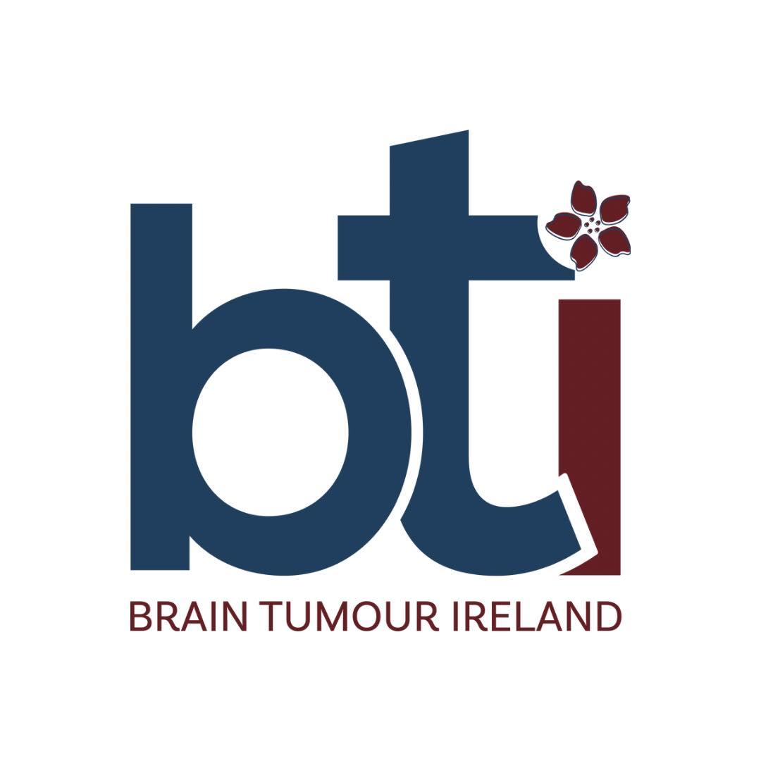
Support Services Coordinator (28 hours per week)
Who We Are
Brain Tumour Ireland was founded in 2012 by a small group of people caring for a family member who was sadly lost to a Brain Tumour. As a national organisation our mission is to provide support and up-to-date information to people with brain tumours, their family/friends/carers, as well as to the medical and other relevant professionals. To raise awareness of and promote education about brain tumours and to support research being carried out.
The Opportunity
We are looking for a highly motivated and empathic person to manage and develop the Brain Tumour Ireland support services, including online and in person support groups, telephone and email support, information sessions and workshops. You will play an instrumental role in developing our support groups nationally and will oversee all aspects of these groups including delivering training to our support group facilitators, monitoring attendance at these groups and ensuring that all policies and procedures are up to date and are in adherence with the governance code.

Please Note
The Support Services Coordinator will provide both telephone and email support to newly diagnosed brain tumour patients and family members. These interactions may be emotionally challenging and require a compassionate and empathic approach, with strong listening skills and the ability to offer support and understanding without needing to provide immediate solutions.

The Person
We are looking for a warm and friendly person with relevant experience of working with similar groups and has an interest in the charity sector. You are a strong communicator who can work as part of a small team as well as independently. You also have a proven ability to work creatively, are solution focused and willing to be involved in all areas of service delivery.

For further information please see our job description.

