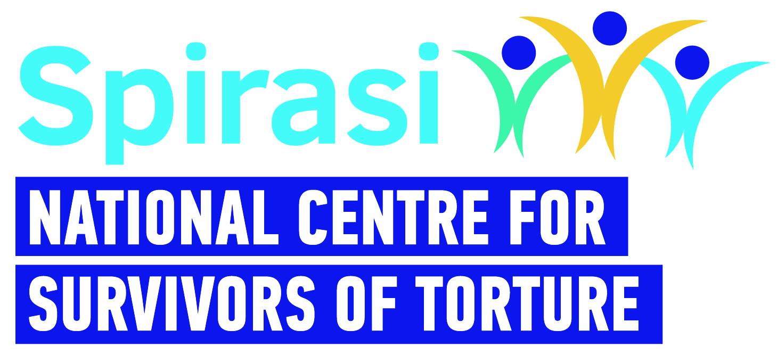

HR Co-Ordinator
Spirasi: A Place of Healing, Hope, and Impact

At Spirasi, we are dedicated to healing survivors of torture and empowering them to rebuild their lives. Through our therapeutic, rehabilitative, and educational services — delivered from our national centre in Dublin — we provide holistic support which helps individuals restore a more integrated sense of self and become active contributors to a better Ireland.

Our Impact

Since our founding, Spirasi has made a tangible difference:
- Over 7,100 survivors of torture have accessed our rehabilitation services.
- More than 2,800 English language students have graduated, gaining confidence and skills to integrate and thrive.
Our work is driven by the belief that every person deserves dignity, healing, and a chance to rebuild. Our team of 40 staff shares this commitment, making Spirasi a truly meaningful place to work.
Why Work With Us?

At Spirasi, you’ll join a passionate and skilled team dedicated to creating lasting change. You’ll contribute to a mission that transforms lives and helps shape a more inclusive, compassionate Ireland.
We now invite applications from suitably qualified and experienced HR Specialists to provide HR support to Spirasi operations.
Position summary:
Spirasi is seeking a capable and proactive HR Co-Ordinator to support our vital work. This key role will co-ordinate day-to-day HR activities — including recruitment, payroll liaison, employee lifecycle documentation, Garda Vetting and policy guidance — ensuring our organisation runs smoothly and our people are well supported.
Person Specification and Job description below:
Please send a CV and a brief cover letter of motivation (no more than 1 page) – both of which should show how your skills and experience match the requirements of the post via email to recruitment@spirasi.ie with ‘Spirasi HR Co-Ordinator and your name’ in the subject of the email. Please make sure that both your CV and cover letter are saved under your name and include the position for which you are applying e.g. First name Last Name Spirasi HR Co-Ordinator.

Applications received without a cover letter will NOT be considered.

Enquiries: Spirasi recruitment - recruitment@spirasi.ie
Closing Date: 5th August 2026
Interview Date: Week commencing 17th August
Remuneration: TBC depending on experience
Contract: 6 months
Hours of work: 7-14 hours/week (1-2 days)
Commencement: TBC
Place of work: Onsite in Dublin 7.
Benefits: EAP with HSF Assist
Enhanced Annual leave (pro-rata)

 | HR Co-Ordinator - Job Description
Title: | HR Co-Ordinator
Work Schedule: | 7-14 hours per week -(1-2 days - depending on the candidate)
Contract Type: | 6 month fixed term
Rate of Pay: | TBC depending on experience
Reporting: | Head of Operations
Location: | Spirasi, 213 North Circular Road, Phibsboro, Dublin 7 with hybrid working in accordance with Spirasi Hybrid working policy.
Main Purpose of Role
Spirasi is seeking to appoint a suitably qualified, capable and proactive HR Co-ordinator to support the day-to-day operations of our organisation, during the implementation of the new strategic plan. This is a key support role, ideal for someone with experience in HR processes and office co-ordination, who thrives in a varied role and is comfortable taking initiative.

You will co-ordinate recruitment and onboarding processes, ensure accurate and timely payroll administration, handle employee lifecycle paperwork, co-ordinate all Garda Vetting and help ensure compliance. You will be a point of reference and support for staff and managers on HR procedures and policies.

Main Responsibilities
- Coordinate end-to-end recruitment processes, including advertising roles, scheduling interviews, reference checks, and issuing contracts.
- Maintain and update employee records, including contracts, leave requests, and other key documentation, using HR Locker among other tools.
- Oversee payroll input and liaise with external payroll providers to ensure accurate and timely processing.
- Support employee onboarding and offboarding processes, including induction scheduling and exit interviews.
- Assist with HR tasks relating to the implementation of the new strategic plan.
- Ensure HR practices comply with employment legislation and internal policies.
- Liaise with IBEC on employment queries as needed and maintain awareness of relevant HR developments.
- Support managers in understanding HR policies and procedures. Assist with general administrative duties as required.
- Prepare reports or data summaries as required (e.g. staff turnover, leave balances).
Person Specification – Knowledge, Skills and Experience Required
Essential
• A relevant qualification in HR.
- At least 2 years’ experience in a similar HR role.
• Knowledge of GDPR and data protection obligations.
• Knowledge of employment law and best practice as it applies to the role of HR
Co-ordinator.
Additional Skills & Attributes
- Possesses experience and understanding of cross-cultural work in HR.
- Strong organisational and administrative skills.
- Ability to manage multiple tasks with good attention to detail.
- Excellent interpersonal and communication skills.
- A self-starter with the ability to work independently and use good judgment.
- Comfortable working in a small organisation and adaptable to changing needs.
- Proficient in IT (Word, Excel, PowerPoint, Email).
- Excellent self-care practices.

Desirable criteria:
- Experience in the not-for-profit or charity sector.
• Familiarity with using IBEC or other employer advisory services.
• Experience using HR software or systems.

Please note:
- This job description is not exhaustive; the post holder may be required to take on additional duties relevant to the role and contribute to its development.
- Garda clearance is a requirement for all Spirasi staff, both upon hiring and throughout employment.
- References will be a prerequisite for employment.
- Candidates must have the right to work in Ireland at the time of application and for the duration of employment.
- Applicants with qualifications obtained outside the Republic of Ireland must provide evidence of validation by the Irish Department of Education at the time of application.
- All personal data received will be processed in accordance with the Data Protection Acts 1988, 2003, and GDPR (2018) and used solely for recruitment and administrative purposes.
- Spirasi is an equal opportunities employer. Recruitment decisions are based on merit, aligned with job and skill requirements.

