Job title | Director of Services & Partnerships (ROI)
Organisation Profile | NOW Group is an award-winning social enterprise operating across Belfast and Dublin. We are committed to working with individuals and businesses to unlock potential and create meaningful, lasting change across the island of Ireland.  Our work focuses on supporting people who are neurodiverse, autistic, or have a learning disability, helping them to build skills and progress into sustainable, future-focused employment. Through tailored training programmes, inclusive job opportunities, and community-based support, we empower individuals to achieve their goals and thrive in the workplace.
Candidate Brief | In this newly created role, you will position NOW Group as a sustainable lead provider for services for people who are neurodiverse, have learning difficulties or intellectual disabilities, by generating income streams from funding, philanthropy, tenders and growth of social enterprise revenue.  Your expertise will ensure that we deliver a world class participant experience and support them to meet their full potential, in line with the organisation strategic vision and objectives.
Location | NOW Group Office ROI – Hybrid working model in place
Reports to | Chief Services Officer
Hours | 37.5 per week
Salary scale | €67,500 to €80,000
Benefits | 25 days annual leave plus 11 statutory days  Health Cash Plan (on successful completion of probationary period)  Access to confidential Staff Counselling & Financial Advisory Services  Pension Scheme  Holiday purchase scheme  Flexible working & Wellbeing initiatives

Main Responsibilities

- Drive growth by boosting existing revenue and creating new income streams
- Identify, evaluate and cultivate high‑value opportunities that strengthen the organisation’s market position, expand income generation, and enhance the profile of NOW Group across all regions.
- Develop, manage and optimise strategic partnerships and stakeholder relationships to advance organisational objectives and long‑term sustainability.
- Oversee the systematic monitoring, analysis and reporting of income diversification, participant outcomes and labour‑market intelligence to inform strategic decision‑making and future service planning.
- Provide strategic leadership for the development and delivery of future employability initiatives, proactively identifying new funding opportunities and acting as a positive policy disruptor to influence, shape and improve the employability landscape.
- Manage, lead and develop the respective Head of Service in Republic of Ireland.
- Actively contribute to the Executive/Leadership Team, shaping organisational strategy, culture and operational effectiveness.
- Implement a robust performance‑management approach to continuously monitor, evaluate and enhance team effectiveness and accountability.
- Ensure the highest standards of safeguarding practice across all services and provide strategic support and leadership in fulfilment of Safeguarding Champion responsibilities.

Garda Vetting

NOW Group adheres to the National Vetting Bureau (Children and Vulnerable Persons) Acts 2012–2016 and it is our policy to obtain Garda Vetting clearance for all employees working within our service delivery teams. This vetting process will be completed prior to commencement of employment, subject to a successful interview outcome.

In line with relevant Irish legislation and best practice, candidates may be asked to disclose convictions and/or pending prosecutions as part of the recruitment process. Please note that a criminal record will not necessarily preclude an individual from obtaining a position.

Job Card

The Job Card below outlines the key outcomes the successful candidate is expected to achieve and defines what success looks like in the role. OTE included and consists of base salary plus performance-related commission, paid subject to achievement of agreed KPIs.

Outcomes | Success Measures | How its Measured
Grow Group Revenue across geographical area (diversified income)  Identify and explore new areas to increase diversified income | Increase revenue, direct services provision and contribution towards organisation growth. Produce data and reports | Financial Control Document  Funding Tracker  Budget
Design and deliver worldclass services with and for people with disabilities either in person or online | Evidence‑based co‑design with participants  High-quality, impactful service delivery aligned to organisational standards | Scorecard metrics (e.g., adults supported, engagement levels)  Net Promoter Score (NPS)  Evidence of collaboration, network development and service innovation
Strengthen Strategic Partnerships to Enable High-Impact Delivery | Recruitment and stewardship of strategic and operational partners  Development of networks that accelerate organisational growth and impact | Recruitment and stewardship of strategic and operational partners  Development of networks that accelerate organisational growth and impact
Develop and implement policies, standards and procedures that ensure compliance and excellence | Demonstrated alignment with government priorities, legislation and regulatory expectations  Robust internal governance and quality assurance processes | Quality Framework  HSE New Directions Policy Knowledge  Peace Plus (SEUPB) audits  Annual Contract Reviews
Increased brand awareness Raise the profile of NOW Group  across the Island of Ireland | Strengthened organisational visibility and reputation  Clear evidence of geographical expansion and increased participant impact  Growth in partner presence across new localities | Net Promoter Score (NPS)  Geographic heat‑map reporting  HubSpot data demonstrating market penetration and audience engagement

Personnel Specification

Essential Criteria

- A full current driving licence and access to a car. Consideration will be given to alternative travelling proposals in respect of applicants with a disability who cannot hold a licence.
- 3rd level qualification in a relevant discipline.
- At least 2 year’s experience;
- negotiating contracts and SLAs with funders;
- producing monitoring reports for a range of service level agreements;
- programme management including direct accountability to funders;
- working at senior management level.
- At least 2 years' experience of managing a budget.
- At least 2 years’ experience of income generation related to service provision.
- Strong experience of liaising with employers and building networks.
- Proficient in the use of the Microsoft Office suite.

Desirable Criteria

- At least 1 years' experience of managing a government funded employment & training programme.
- At least 1 years' experience of taking a lead role in; a major Irish government and HSE-funded programme oversight, audit, or inspection, HIQA inspections, HSE audit and compliance processes, self-evaluation and quality improvement processes
- Experience of safeguarding, with a clear understanding of policies, procedures, and responsibilities in protecting vulnerable individuals.

Values & Behaviours

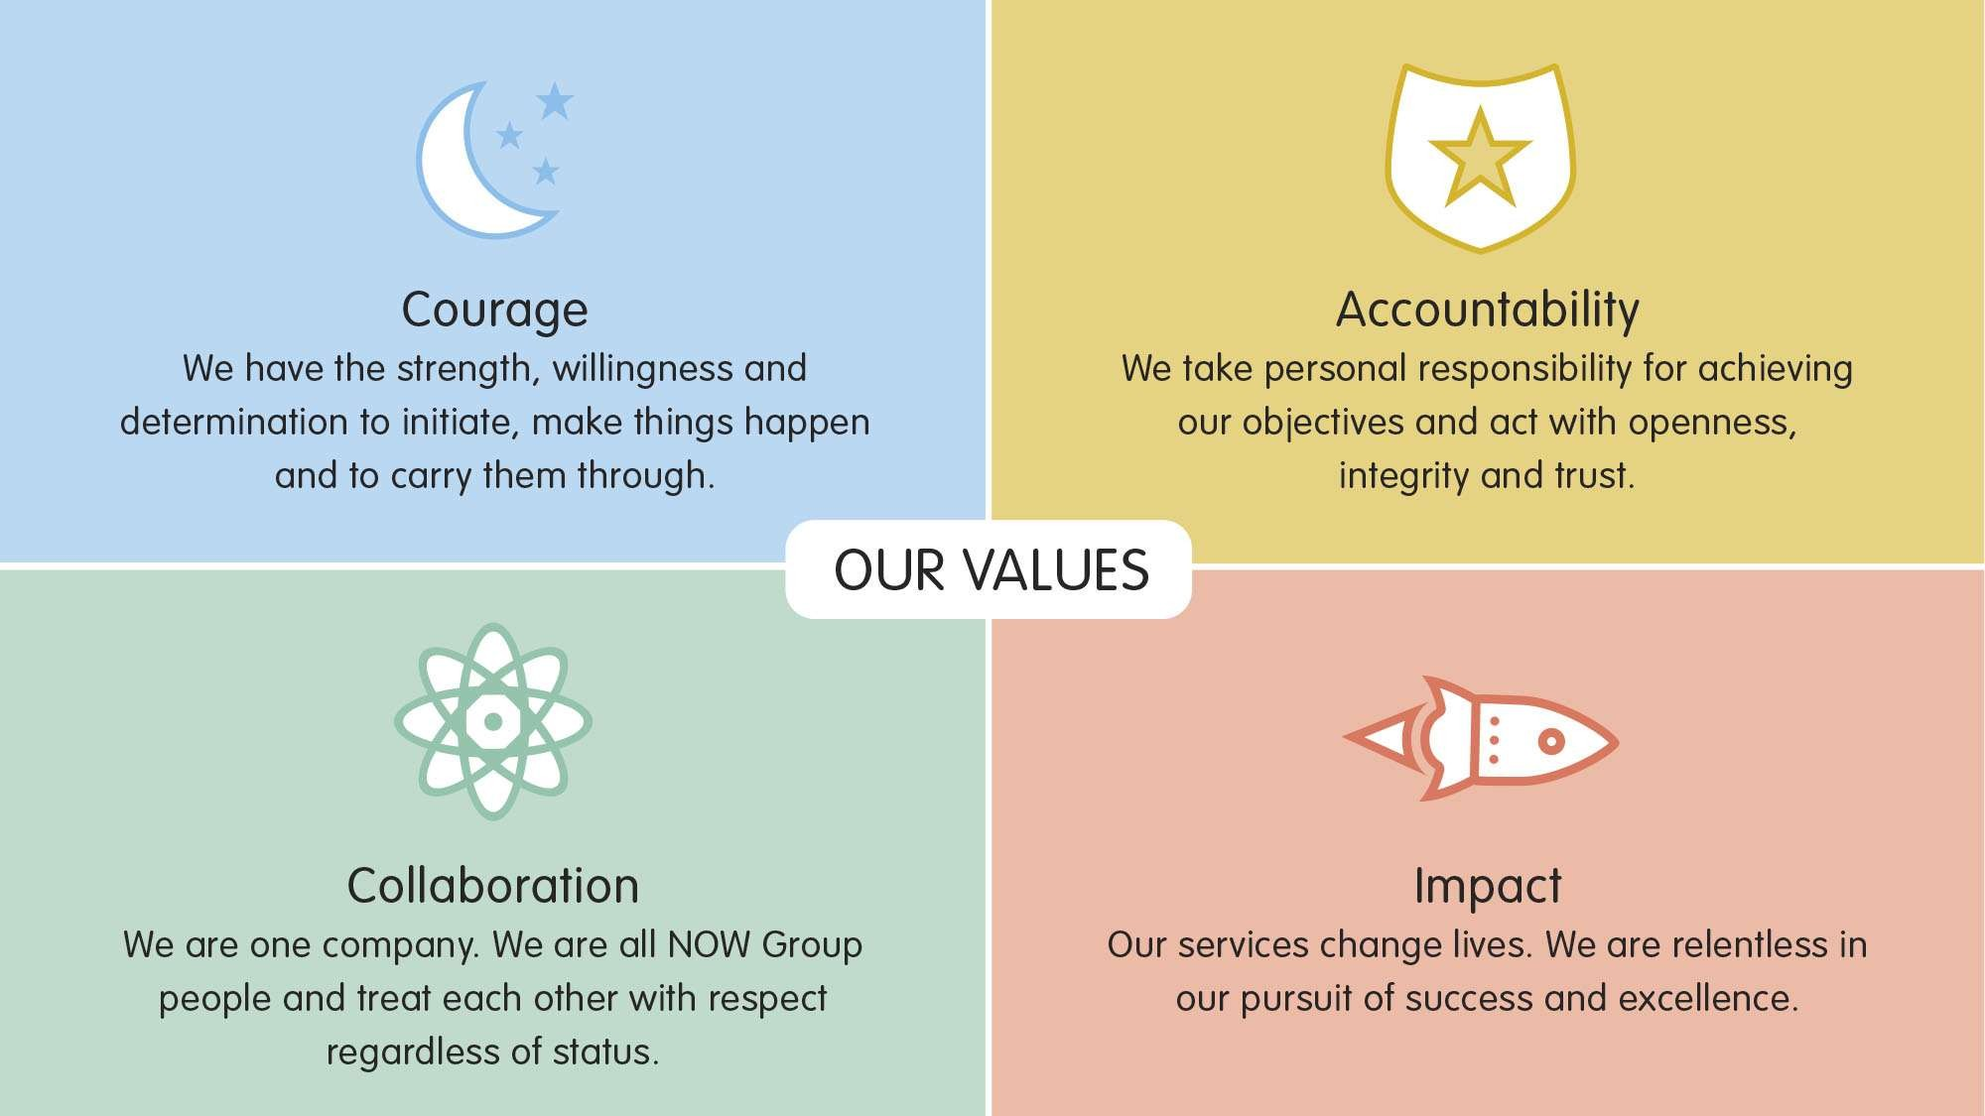

All employees in NOW Group are required to subscribe to the values of the organisation and demonstrate these values through agreed behaviours in their day to day work and their relationships with participants, stakeholders and colleagues. Candidates will be expected to demonstrate relevant values and behaviours as part of the interview process.

