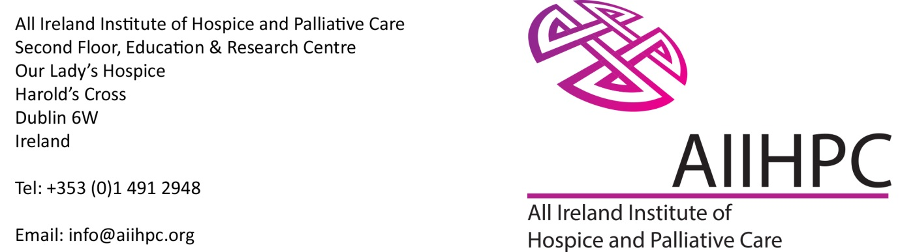

Communications Project Manager
A vacancy has arisen for a Communications Project Manager in the All Ireland Institute of Hospice and Palliative Care (AIIHPC).
AIIHPC is a collaborative of hospices, universities, health and social care organisations and charities on the island of Ireland. AIIHPC advances education, research, and policy and practice to improve the palliative care experience of people with life-limiting conditions and their families
Communications Project Manager
Reporting to the Programme Manager - Policy and Engagement, the post-holder will develop and implement communications plans and associated activities in pursuance of AIIHPC’s mission to improve palliative care, across all AIIHPC’s work areas. The post-holder will identify mechanisms through which AIIHPC can promote greater understanding of palliative care through supporting Palliative Care Week, the promotion of The Palliative Hub and AIIHPC’s research, policy and engagement and education and practice programmes while also generating awareness of AIIHPC across the island of Ireland and internationally.
The post is a 0.8 WTE / 4 days per week specified purpose contract (Until mid October 2026) with a salary of €53,018 - €59,541 per annum pro rota. Salary is strictly calculated based on level of experience.
Informal enquiries for the above to: Catherine Brady, Office Manager, AIIHPC.
Phone: 00353 871883745 or email: cbrady@aiihpc.org
Please note the interview date for the post has been set for Friday 19 June
Closing date for receipt of applications is 12noon, Thursday 11 June 2026
Please click on this links to view more detail on the role below including the detailed Job Description
Applications should be completed through this Link and will include a CV and written statement.
All Ireland Institute of Hospice and Palliative Care is based at Our Lady’s Hospice and Care Services, Harold’s Cross, Dublin 6W. Tel: +353 (0)1 491 2948. www.aiihpc.org

