Job title | Food & Beverage Team Member (with driving duties)
Main Function | NOW Group are an award-winning social enterprise who support people with intellectual disabilities and autism into jobs with a future.  We are expanding our services at our vibrant Café in Kilmainham Square, Dublin 8 and are seeking a Food & Beverage Team Member who can support with food preparation and delivery of our corporate catering to customers across Dublin, while creating training and employment opportunities for local people with intellectual disabilities and autism.
Location | Unit 2 Building 1 Old Chocolate Factory, Kilmainham Square, Inchicore Road, Dublin 8
Reports to | Hospitality Operations Manager
Hourly rate: | €14.15
Hours per week | Adhoc across Monday to Friday
Benefits | 25 days annual leave plus 11 statutory days (pro-rata)  Health Cash Plan & Pension Scheme (on successful completion of probation)  Holiday purchase scheme  Flexible working initiatives  Wellbeing initiatives

Mission

Supporting people with intellectual disabilities and autism into jobs with a future.

Vision

A society where people with intellectual disabilities live, work and socialize as valued citizens.

Main Responsibilities

- Deliver events and catering services to customers across Dublin.
- Inspire and support NOW Group catering students through provision of training and assessment opportunities in conjunction with training staff.
- Be an ambassador for Loaf Catering, providing excellent service to internal and external customers.
- Deliver and prepare food and drink for our visitors in line with Loaf quality standards
- Carry out cleaning tasks as per the daily/weekly schedule to a high standard.
- Adhere to existing work practices, methods and procedures.
- Maintain confidentiality and observe data protection and associated guidelines, where appropriate.
- Ensure security and safety of staff, participants, premises, stock and cash at all times.
- To follow Health and Safety Regulations including Fire, Hygiene H.A.C.C.P and C.O.S.S.H.
- Carry out any other reasonable duties within the overall job function.

This job description in not definitive and may be subjective to review as the duties and the
responsibilities determine. Please note that employment with NOW Group may be subject to a check from the Garda Vetting Bureau.

Personnel Specification

Essential
- Valid Drivers Licence.
- Ability to work under pressure
- A can –do attitude.
- Ability to work evening/weekends as & when required.
- Previous experience (paid or voluntary) of working in a busy catering environment.

Desirable
- Essential Food Hygiene Certificate
- Experience of keeping records
- Knowledge and understanding of the needs of disabled people and a commitment to the equal rights.
- Experience of dealing with customers.

Values & Behaviours

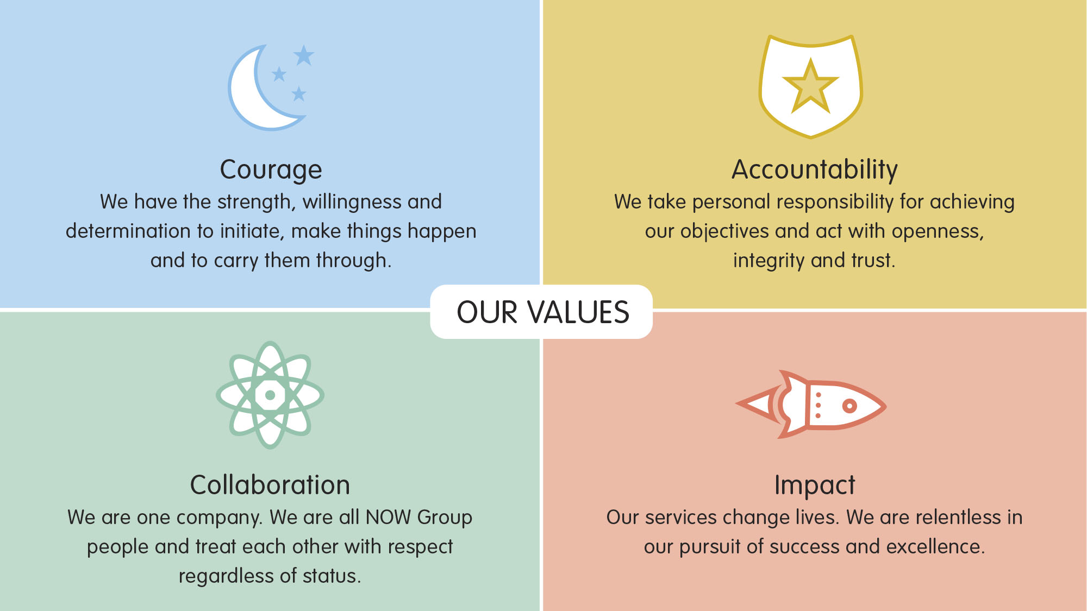

All employees in NOW Group are required to subscribe to the values of the organisation and demonstrate these values through agreed behaviours in their day to day work and their relationships with participants, stakeholders and colleagues. Candidates will be expected to demonstrate relevant values and behaviours as part of the interview process.

