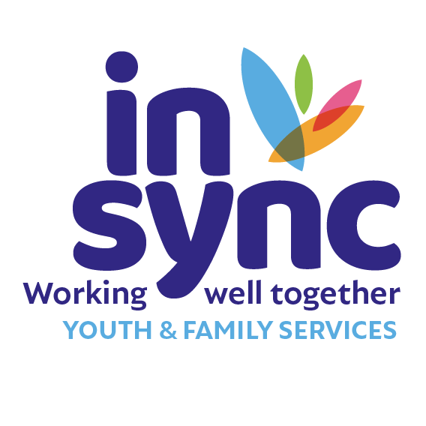

JOB DESCRIPTION: COMMUNICATIONS OFFICER

In Sync Youth & Family Services provides therapeutic and youth work services to young people, children and families in Kildare and West Wicklow and advocates and collaborates for improved access to services and better outcomes for young people, children and families. In Sync is committed to the provision of quality youth & family services through an integrated multi-disciplinary approach.

Our Vision is of a more inclusive, fair, equal, safe society where young people, children and families are supported and valued equally.

In Sync operates in 13 locations across Kildare & West Wicklow and employs up to 85 people from a variety of professions across these locations.

Job Title: Communications Officer

Location: The office base will be in Head Office, Naas, Co. Kildare, with
the requirement to travel across Kildare & West Wicklow as
required.

Reporting to: Chief Executive Officer

Function: The Communications Officer will be responsible for leading
the Communications functions of the organisation.

Contract: 12mth fixed term contract, with 6 months probation period

Working Hours: 38 hours per week.
In Sync operates a Time Off In Lieu (TOIL) system for hours worked over the contracted hours.
Key Responsibilities:

- Develop and deliver on the Communications Implementation Plan that is drawn from the In Sync Strategic Plan.

- Lead the development and implementation of a Communications Strategy that guides and informs the communications functions of the organisation.

- Ensure the In Sync Communications Strategy:
- Is informed by and supports the direct engagement of young people, children, and families, staff, and volunteers in our communications output.
- Clearly promotes and reflects our values and our models work,
- effectively articulates the value and impact of the work we do, and
- Communicates the outcomes-focused approach to our work with young people, children, and families, and the wider community.

- Work with the Board and SMT to develop an advocacy agenda that is informed by an inclusive internal consultation process. Develop a plan that supports the implementation of that agenda, including the development of a suite of position statements on identified themes and issues.

- Lead the further development and roll out of In Sync branding, oversee and monitor the use of branding to ensure consistency across the organisation.

- Responsible for the management and administration of insync.ie website and social media platforms, and the ParentingSupport.ie website.

- Produce high-quality written, visual and digital content i.e. press releases, videos, reports, leaflets, posters etc.

- Represent and promote the organisation at a national and regional level to relevant bodies, networks, and fora with a view to promoting our services, exchanging ideas and accomplishing objectives e.g. YWI Communications Network.

- Build and maintain collaborative and productive relationships with key external stakeholders at a local and regional level in order to further the interests of In Sync and of young people, children and families in Kildare & West Wicklow i.e.
- Partners and funders
- Print media, radio etc.; and,
- Elected representatives and their staff.

- To be cognisant of and responsive to the broader environment in order to identify opportunities and/or threats for In Sync.

- To ensure implementation of, and compliance with, In Sync Policies and Procedures.

- Review communications operations on an ongoing basis to evaluate performance and effectiveness in meeting objectives, and to determine areas of potential opportunity and areas of potential risk.

- To support and promote In Sync's positive and progressive culture, as articulated in the organisations values, for the benefit of staff, volunteers and young people.

- To be innovative in developing new and creative ways of communicating our messages.

- Support the upskilling of the In Sync staff team to improve effectiveness of communications output at all levels.

- Support the identification of opportunities and strategies for the growth and development of our services in Co. Kildare & West Wicklow.

- This job description may be reviewed from time to time in line with the needs of the organisation.

Skills, Knowledge & Experience
- Proven experience of managing and updating websites using WordPress
- Experience managing organisational social media platforms, ideally in the community & voluntary sector.
- Proficiency in Canva, video editing tools, and Microsoft Office applications (Word, Excel, PowerPoint, Publisher).
- Strong digital content creation skills, including producing engaging posts, short form videos and reels, and the ability to identify and respond to emerging social media trends
- Strong copywriting and storytelling ability
- Ability to manage multiple projects and priorities
- Excellent verbal and written communication skills
- ability to work collaboratively across multi-disciplinary teams

