Job title | Trainer – 3 roles  1 to cover Cavan County  1 to cover Louth County  1 to cover Monaghan County
Candidate Brief | NOW Group is a social enterprise committed to supporting people with learning difficulties and autism into sustainable employment and meaningful lives. We deliver a range of services including training, employment support, and social enterprise initiatives across the Island of Ireland.  We are seeking an experienced and passionate Trainer who will play a key role in a transformative cross-border initiative that empowers people with disabilities through skills development, training academies, and meaningful employment pathways.  The successful candidate will provide participants with the highest quality support to enable achievement of skills development and educational aspirations. You will focus on the development, direct delivery, and assessment of academy-based training courses and pre-employment academies. This will include structured, academy-led programmes in key sectors such as; Hospitality and Tourism, Health and Social Care, and the Green Economy.  This role is part of Skills Connect, a project funded by PEACEPLUS and managed by the Special EU Programmes Body (SEUPB).
Location | Remote working – role requires travel throughout the relevant County
Reports to | Training and Employability Manager
Hours | 37.5 hours per week
Salary scale | €38,000 per annum (4 year project)
Benefits | 25 days annual leave plus 11 statutory days (pro-rata)  Health Cash Plan (on successful completion of probationary period)  Access to confidential Staff Counselling & Financial Advisory Services  Stakeholder Pension Scheme (5% employer contribution)  Bike 2 Work Scheme  Holiday purchase scheme  Flexible working initiatives  Wellbeing initiatives

Mission

Supporting people with learning difficulties and autism into jobs with a future.

Vision

A society where people with learning difficulties live, work and socialize as valued citizens.

Main Responsibilities

- Conduct thorough participant inductions, including initial suitability assessments and ongoing formative evaluations, to support tailored learning and development. This may include; Utilising a range of assessment methods to effectively evaluate and evidence the competence and progress of individual participants.
- Collaborate with participants and Employment Liaison Officers to co-design, implement, and regularly review personalised development plans, whilst reviewing milestone stages of the participant progression journey.
- Develop and deliver academy-based training programmes aligned with current labour market needs in the Hospitality and Tourism, Health and Social Care, and Green Economy sectors.
- Design, develop, and deliver accredited skills-based employability training academies by creating comprehensive schemes of work and detailed lesson plans tailored to participant needs, employer skills shortages and industry standards.
- Ensure the delivery of Skills Connect academies aligns with employer requirements and job entry criteria by actively engaging with strategic job partners to maintain a collaborative and responsive approach.
- Adhere to the operating procedures and policies of the relevant awarding bodies, including all requirements related to internal and external verification.
- Deliver Equality, Diversity, and Inclusion training to strengthen the capacity of local employers and communities in fostering inclusive and equitable environments.
- Demonstrate proficiency in delivering training using a range of multimedia tools, technologies, and equipment to enhance participant engagement and learning outcomes.
- To Support the monitoring and evaluation of the project by capturing participant progress, maintaining accurate records of attendance, and documenting service outcomes and outputs to track impact and inform reporting internally and externally.

This job description is not definitive and may be subject to review as the duties and responsibilities determine.

Please note that employment with NOW Group may be subject to a check from the Garda Vetting Bureau.

Personnel Specification

Essential
- A full current driving license and access to a car. Consideration will be given to alternative travelling proposals in respect of applicants with a disability who cannot hold a license.
- Leaving Certificate in English and Maths or equivalent.
- Minimum of 1 year’s paid experience in direct provision training.
- Experience of delivering training in one of the following vocational areas; Customer Service; Catering & Hospitality; Employability; Health and Social Care
- Minium of 1 year’s paid experience delivering accredited training programmes to either:
- Children or young people
- Adults with barriers to learning
- Participants with learning disabilities/difficulties
- Proven experience of working with Awarding Bodies.
- Experience of assessment and moderation.
- Proficient in the use of the Microsoft Office suite.

Desirable
1. Hold Internal verifier/ moderator qualifications

Shortlisting will be based on the evidence that you supply on your application form to satisfactorily demonstrate how, and to what extent, you meet the above criteria. The shortlisting panel will not make assumptions as to your circumstances, qualifications, and experience.

Values & Behaviours

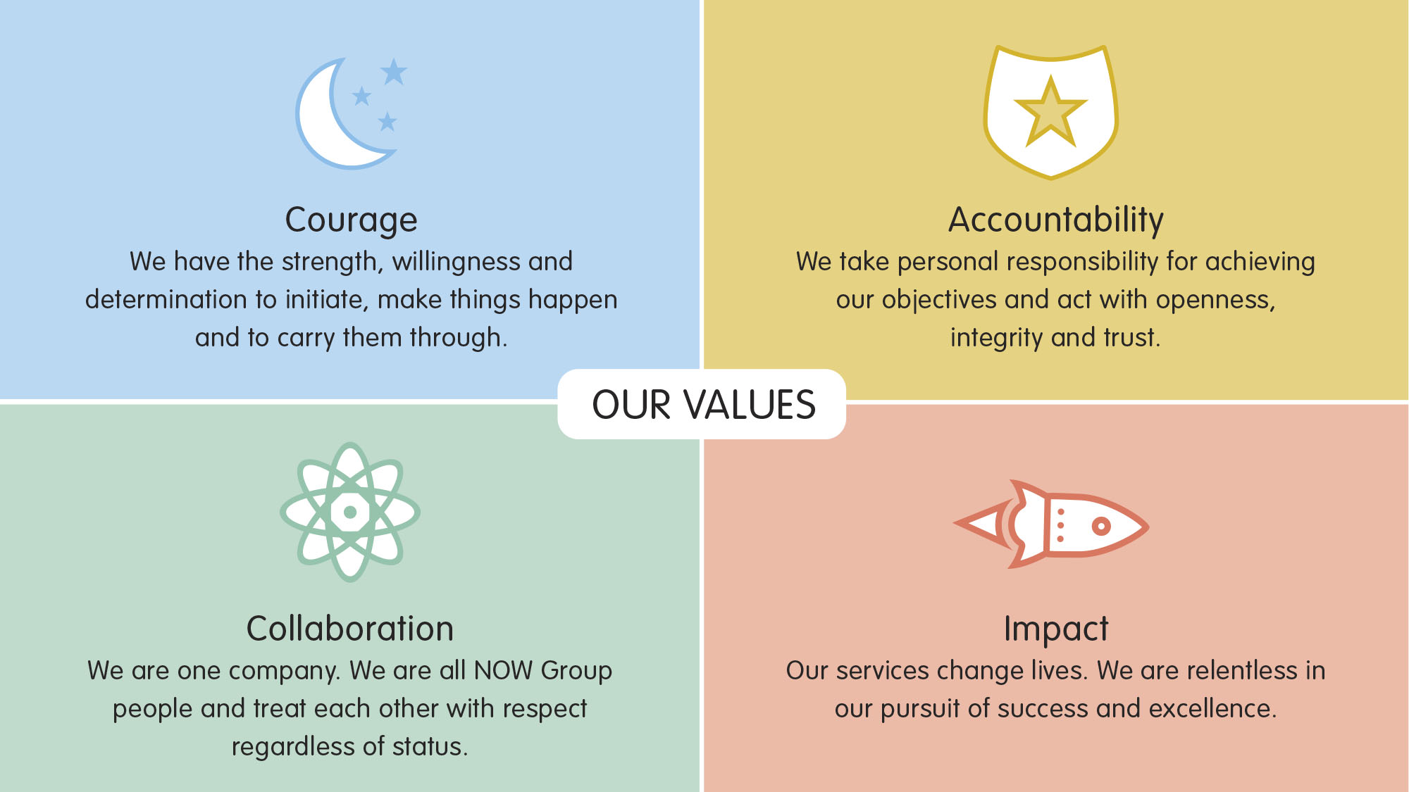

All employees in NOW Group are required to subscribe to the values of the organisation and demonstrate these values through agreed behaviours in their day-to-day work and their relationships with participants, stakeholders and colleagues. Candidates will be expected to demonstrate relevant values and behaviours as part of the interview process.

