Terms of Reference (TOR): Procurement of Professional Technology Trainer and Freelancer

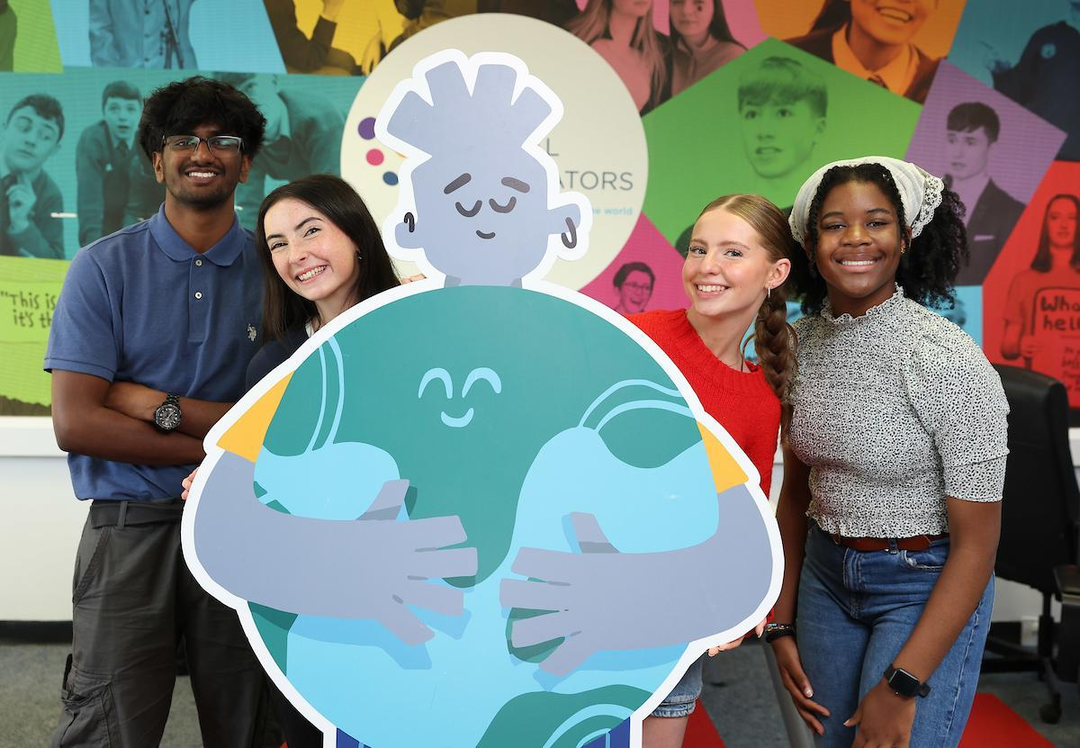

1. Overview
Title: Procurement of Professional Technology Trainer and Freelance Facilitator
Issue Date: 26th November 2025
Closing Date for Submissions: 11th December 2025 at 12pm
Contract Period: 18th December 2025 – 31st December 2026
Budget: Euro 22,860 (inclusive of VAT)
Contact for Queries: stephen.mccrudden@youngsocialinnovators.ie
Submission Instructions: see enclosed for instructions.

2. Background and Rationale

About Young Social Innovators (YSI)
Young Social Innovators (YSI) is a non-profit organisation dedicated to empowering young people to use their creativity, energy, and ideas to tackle real-world social challenges. Since its establishment in 2001, YSI has engaged over 187,000 young people across Ireland in youth-led innovation projects that promote social justice, inclusion, and sustainability.
YSI’s award-winning programmes build essential skills in critical thinking, collaboration, innovation, and leadership, enabling young people to become confident, active citizens. Working with schools, youth groups, and community organisations, YSI supports young people to design and implement projects that drive meaningful change — addressing issues from mental health and climate action to digital inclusion and community development.
The Ignite Community (IC) Programme, under which this procurement sits, is a cross-community initiative designed to build digital skills and social connections across Northern Ireland (NI) and the Border Regions of Ireland (BRI). The programme promotes inclusive innovation, encouraging young people from diverse backgrounds to collaborate through technology and creative problem-solving.
The IC programme is funded by the SEUPB under the current PEACEPLUS funds and is a partnership with Donegal Youth Services, Kippie, Arts Care and HAPANI. YSI is the lead partner and responsible for the overall programme and financial management of the programme.

Purpose of This Procurement
YSI is seeking to engage an experienced professional technology trainer/freelancer to deliver the Code Club component of the Ignite Community Programme.
The successful contractor will:
- Deliver training for adult Guides and youth Mini Guides.
- Support the establishment and sustainability of 12 innovative mobile Code Clubs or Tech Hubs designed to enable Ignite Community partners to make the programme accessible to all young people, regardless of geography, background, or ability.

  - These hubs will act as flexible, creative spaces for learning and innovation, capable of reaching diverse communities through mobile or locally adaptable formats.
  - This approach aligns directly with YSI’s core strategic objective of building a world-class social innovation experience that is accessible to every young person and of using technology as an enabler to strengthen human connection, collaboration, and empowerment.
- Facilitate 4 Hackathons to build creativity, confidence, and community innovation.
- Propose a solution for the equipment supply of Code Club Kits sufficient to support 12 Code Clubs (i.e. approximately 6 kits).
Through this contract, YSI aims to expand the Ignite Community’s capacity to embed digital and social innovation learning within community networks, bridging access gaps and ensuring all young people — including those from rural, marginalised, or underrepresented communities — can participate fully.

3. Objectives
The purpose of this assignment is to strengthen the capacity of communities and young people to use technology as a driver of social innovation, peace building, and inclusion.
Key Objectives:
1. Establish and operationalise 12 sustainable Code Clubs.
2. Train and mentor up to 80 adult Guides and 60 Mini Guides.
3. Deliver 4 youth Hackathons promoting innovation and social impact.
4. Propose a solution for the equipment supply of Code Club Kits sufficient to support 12 Code Clubs (i.e. approximately 6 kits). The proposal should include:
- Recommended hardware and devices suitable for coding activities, including suggested quantities per kit.
- Peripherals and accessories necessary for effective club delivery (e.g. keyboards, mice, power supplies, storage media).
- Learning resources and software to support beginner to intermediate coding activities.
- Connectivity and networking solutions to enable collaborative learning.
- Storage and mobility solutions to allow safe transport and secure storage of the kits.
- Support and warranty options, including set-up assistance and technical support.

5. Produce comprehensive training materials and documentation. It is anticipated that the successful contractor will work closely with current YSI staff on development of training materials aligning to other YSI technology offerings.
6. Promote cross-community collaboration, equality, and empowerment.

4. Scope of Work
The scope of work outlined below provides a suggested framework for the contract. YSI is keen to encourage innovation and welcomes proposals from freelancers that demonstrate creative approaches, new methodologies, or enhanced content, provided they remain aligned with the overall objectives and outcomes of the Ignite Community Programme.

A. Training and Capacity Building
- Design and deliver engaging training sessions in:
• Coding (i.e. Scratch, Python, Web)
• Mentorship and facilitation
• Safeguarding and youth engagement
• Social innovation and project-based learning
- YSI’s strong preference is for all training to be delivered in person, to maximise engagement, peer learning, and relationship building across communities (Hybrid or online options may be used where necessary, such as for accessibility or logistical reasons, but these should be the exception rather than the norm).
- Provide mentoring and ongoing support for both Guides and Mini Guides during the period of the contract.

B. Code Club Establishment
- Support the setup and launch of 12 Code Clubs.
- Provide technical advice, software guidance, and logistics support.
- Recommend, specify, and coordinate provision of Code Club kits sufficient to support 12 clubs (approximately 6 kits), including hardware, software, peripherals, and storage solutions.

- Train guides and mini-guides who will lead and facilitate the Code Clubs, ensuring knowledge transfer and ongoing capacity
- Develop sustainability and transition plans with local hosts.

C. Hackathon Delivery
- Design, plan, and facilitate 4 Hackathons throughout the contract.
- Integrate social innovation challenges into each event.
- Proposed Hackathon Location: Microsoft DreamSpace, Belfast.
- Ensure cross-community, gender-balanced, and inclusive participation through partnership support.

D. Monitoring, Evaluation, and Reporting
- Record participation metrics, feedback, and learning outcomes.
- Submit quarterly progress reports and a final evaluation.
- Document success stories and provide recommendations for future delivery.

5. Deliverables and Timeline

Deliverable | Target Output / Quantity | Indicative Timeline
Contract commencement | N/A | 18th December 2025
Training for Guides and Mini Guides | 80 adults + 60 young people | Jan – July 2026
Code Clubs established and operational | 12 | Jan – July 2026
Mobile Code Club kits spec provided | 6 | 1st January 2026
Hackathons delivered | 4 | Mar, May, Sept, Dec 2026
Training materials and resources | 1 complete set | Jan 2026
Monitoring and evaluation reports | Quarterly + Final | Mar, June, Sept, Dec 2026
Final sign-off report | 1 | 31st December 2026

6. Governance and Management
- The successful contractor will report to the YSI Programme Lead (Ignite Community Programme).
- Regular progress meetings will be held to review milestones and performance.
- YSI will provide access to partner organisations, youth groups, and local networks.
- Compliance with YSI’s safeguarding, equality, and quality assurance standards is mandatory.

7. Supplier Requirements
Applicants must demonstrate:
- Proven experience delivering coding or digital skills training to adults and young people.
- Strong facilitation and mentoring skills, particularly in community or youth settings.
- Familiarity with cross-community engagement in NI and/or BRI.
- Experience in planning and facilitating Hackathons or innovation events.
- Comprehensive safeguarding, equality, and data protection policies.
- Ability to manage technical logistics and provide necessary equipment.
- Excellent communication and interpersonal skills.

8. Budget and Submission Requirements

Budget Proposal
The financial proposal must include a complete and transparent cost breakdown covering:
- Training delivery fees
- Hackathon design and delivery costs (Please note that we are hopeful that Microsoft will supply the Dream Space venue FOC and have volunteers on hand to facilitate Hackathons – TBC)
- Equipment and materials.
- Travel and accommodation costs for the contractor (to be covered by the contractor and built into the overall price)
- Administrative and overhead costs
- VAT (if applicable)
Bidders should ensure that their budget accounts for all necessary logistics and travel requirements associated with delivering the contract effectively across multiple locations.

Submission Documents
- Technical and financial proposals
- Work plan and timeline
- CV(s) of key personnel or freelancer
- Evidence of relevant experience
- Signed declaration
- Two professional references

9. Evaluation Criteria
Understanding of the brief & proposal quality – 25%
Relevant experience & technical capacity – 25%
Methodology & timeline – 20%
Cost and value for money – 20%
Social / added value – 10%
Assessment Process:
1. Evaluation of written tenders.
2. Interview and presentation for shortlisted candidates.
3. Final decision based on combined scoring.
YSI reserves the right not to award the contract should submissions not meet the required standard.

10. Ethical and Legal Considerations
- The successful candidate must comply with YSI’s safeguarding, equality, and data protection policies at all times.
- Garda Vetting (Republic of Ireland) or AccessNI Vetting (Northern Ireland) is mandatory prior to engagement, depending on the location of service delivery.
- The contractor must hold valid public liability and professional indemnity insurance.
- All intellectual property rights for training materials produced will rest with YSI.
- All activities must reflect YSI’s values of inclusivity, empowerment, collaboration, and innovation.
- The contractor must act with integrity, maintain confidentiality, and uphold the highest professional standards throughout the engagement.

