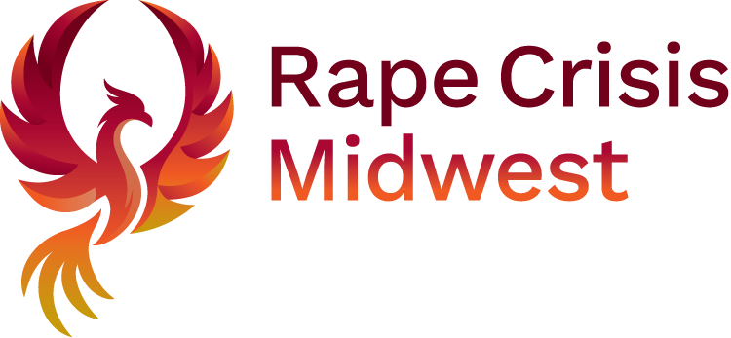

Please read the Job Description & Specification, which provides useful information about the requirements of this role.

|  |  |
| --- | --- |
| **Closing Date & Time** | 12th September 2025 @ 5pm |
| **Return application forms by email to** | [recruitment@rapecrisis.ie](mailto:recruitment@rapecrisis.ie)  **Please note that you must submit your application form via email only** |
| **Anticipated Interview Date(s)** | Proposed interview dates will be indicated at a later stage. Please note you may be called forward for interview at short notice**.** |

**APPLICANT DETAILS**

|  |  |
| --- | --- |
| Position Applied For: |  |
| **Personal Details** |  |
| First Name: |  |
| Last Name: |  |
|  |  |
| Address |  |
|  |
|  |

|  |  |
| --- | --- |
| Mobile Telephone |  |

|  |  |
| --- | --- |
| Email Address **(mandatory)**:  (You may provide more than one) |  |

**QUALIFICATIONS & ELIGIBILITY CRITERIA**

Please indicate below how your qualifications and professional experience meet the eligibility criteria for the role. **Please note that if you omit information in this section pertinent to the eligibility criteria you will be deemed ineligible and subsequently not called forward to interview.** Please complete each section below.

|  |  |  |  |  |  |
| --- | --- | --- | --- | --- | --- |
| **Dates**  **From / To** | **Educational Institution** | **Conferring Body** | **Course of Study** | **Qualification Achieved** | **Grades Achieved** |
|  |  |  |  |  |  |
|  |  |  |  |  |  |
|  |  |  |  |  |  |

**EDUCATIONAL ACHIEVEMENTS**

**Please list your second level and any (additional) third level educational achievements.**

|  |  |  |  |  |  |
| --- | --- | --- | --- | --- | --- |
| **Dates**  **From/To** | **Educational Institution** | **Conferring**  **Body** | **Course of Study** | **Qualification Achieved** | **Grades Achieved** |
|  |  |  |  |  |  |
|  |  |  |  |  |  |
|  |  |  |  |  |  |
|  |  |  |  |  |  |

**CAREER OVERVIEW**

Please ensure your full career history is clearly outlined below (e.g. if you took a career break, spent time out of work, please include this information so there are **no gaps in your career history** from when you left full-time education to present date).

|  |  |  |  |
| --- | --- | --- | --- |
| **From** | **To** | **Title** | **Employer** |
|  |  |  |  |
|  |  |  |  |
|  |  |  |  |
|  |  |  |  |
|  |  |  |  |

|  |
| --- |
| **Experience Relevant To The Role**  Please provide below specific details from your experience to date that you feel help you meet the requirements for this post as detailed in the Job Specification. Please note that the information supplied here will be taken into consideration in determining your eligibility and / or shortlisting / ranking for this campaign. |
| **Describe your experience in managing the finances of a charity, non-profit, or similar organisation, including preparing budgets, financial reports, and ensuring compliance with relevant legislation.** |

|  |
| --- |
| **Experience Relevant To The Role**  Please provide below specific details from your experience to date that you feel help you meet the requirements for this post as detailed in the Job Specification. Please note that the information supplied here will be taken into consideration in determining your eligibility and / or shortlisting / ranking for this campaign. |
| **Give an example of a time you identified a financial risk or challenge within an organisation and how you addressed it. What was the outcome?** |

|  |
| --- |
| **Experience Relevant To The Role**  Please provide below specific details from your experience to date that you feel help you meet the requirements for this post as detailed in the Job Specification. Please note that the information supplied here will be taken into consideration in determining your eligibility and / or shortlisting / ranking for this campaign. |
| ***This role requires sensitivity to the work of a rape crisis centre and the issues faced by survivors. How would you ensure your financial management approach supports the organisation’s values, mission, and service delivery?*** |

**General Declaration**

“I declare that to the best of my knowledge and belief there is nothing in relation to my conduct, character or personal background of any nature that would adversely affect the position of trust in which I would be placed by virtue of my appointment to this position. I hereby confirm my irrevocable consent to the Rape Crisis Midwest to the making of such enquiries, as the Rape Crisis Midwest deems necessary in respect of my suitability for the post in respect of which this application is made.

I hereby accept and confirm the entitlement of the Rape Crisis Midwest to reject my application or terminate my employment (in the event of a contract of employment having been entered into) if I have omitted to furnish the Rape Crisis Midwest with any information relevant to my application or to my continued employment with the Rape Crisis Midwest or where I have made any false statement or misrepresentation relevant to this application or my continuing employment with Rape Crisis Midwest.

Furthermore, I hereby declare that all the particulars furnished in connection with this application are true, and that I am aware of the qualifications and particulars for this position. I understand that Garda Vetting is a requirement for the role. I understand that I may be required to submit documentary evidence in support of any particulars given by me on my Application Form. I understand that any false or misleading information submitted by me will render me liable to automatic disqualification or render me liable to dismissal, if employed.”

**Signed:**

*(Name of Applicant)*

**Date:**

NB: If you are submitting your application form via email we will accept the application form unsigned but you will be required to sign the Declaration at interview should you be invited to one. Failure to sign this declaration at interview will render it invalid.