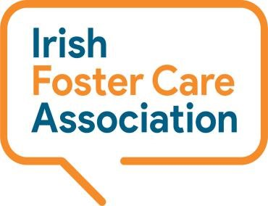

**Synergy Centre**

**TU Dublin Campus**

**Tallaght**

**Dublin 24, D24A386**

**Tel: 01 459 9474**

**National Helpline Service - Volunteer Application Form**

**Please complete this form and return via email to** [**volunteer@ifca.ie**](mailto:volunteer@ifca.ie) **or post to the above address.**

|  |  |
| --- | --- |
| **Surname:** |  |
| **First Name:** |  |
| **Address:** |  |
| **Telephone:** |  |
| **Date:** |  |
| **Email:** |  |

**Please tell us why do you want to volunteer on the National Helpline Service?**

|  |
| --- |
|  |
|  |
|  |
|  |
|  |
|  |

**Please tell us what you hope to gain from your experience with us?**

|  |
| --- |
|  |
|  |
|  |
|  |
|  |
|  |

**Please tell us about any educational background, work or volunteering experience that would be relevant to the volunteer role you are applying for.**

|  |
| --- |
|  |
|  |
|  |
|  |
|  |
|  |

**Please tell us of any other hobbies, skills, special interests or qualities you have that may be relevant to the volunteer role you are applying for?**

|  |
| --- |
|  |
|  |
|  |
|  |
|  |
|  |

**The Helpline runs Monday to Friday 11am to 3pm and our Volunteers support the Helpline one day a week in this time. Is there a day/times that suit you or please feed back any other comments on your availability?**

|  |
| --- |
|  |
|  |
|  |
|  |
|  |
|  |

**The Counselling Skills course is an essential part of our training for the role. Information for the 2025 course as follows: -**

***Counselling Skills Course Level 6 with the Irish College of Humanities and Applied Sciences (ICHAS) in Limerick, Dublin and Cork, starting October 2025. Includes 4 workshops from October to end of November on Saturdays from 9.30 to 4.30pm.***

**Can you confirm your availability to commit to this as part of your Helpline Induction and Training programme, please comment below?**

***(Note: Applicants can seek an exemption where they have already done a module in Counselling or similar at Level 6 or above)***

|  |
| --- |
|  |
|  |
|  |
|  |
|  |

**References: Please supply us with the names of two referees (non-relatives)**

|  |  |
| --- | --- |
| **Name:** |  |
| **Address:** |  |
| **Email:** |  |
| **Telephone** |  |

|  |  |
| --- | --- |
| **Name:** |  |
| **Address:** |  |
| **Email:** |  |
| **Telephone** |  |

**Do you have any special needs you would like to share with us or is there anything else you would like to share?**

|  |
| --- |
|  |
|  |
|  |
|  |
|  |
|  |

***\*\*Note: Interview and Garda Vetting is a requirement for all Helpline volunteer roles\*\****