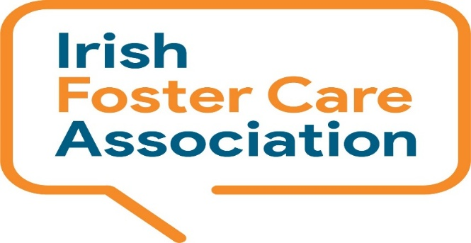
Irish Foster Care Association
National Helpline Service
Seeking Volunteers -
Full Training & Support will be provided

Are you interested in working on a National Helpline Service? Can you give 4 hours one day a week?

About Us
The Irish Foster Care Association (IFCA) is the national organisation that supports foster families and the wider fostering community. We advance and promote best practice in foster care through support, learning and advocacy. Membership is broad based and includes foster and relative carers, social workers, child care workers, academics and others with an interest in or who are involved in foster care. For more information please visit our website: www.ifca.ie.
Registered Charity Number: CRA No: 20036690
CHY No: 12498

National Helpline Service
IFCA’s National Helpline Service is a confidential helpline service who offer independent, objective, non-judgmental and a supportive space to discuss and explore issues of concern relating to foster care.
The National Helpline Service is managed by trained and certified staff and volunteers, some of who are Foster Carers, providing a telephone, email, and webchat support service from Monday – Friday 11am – 3pm.

Volunteer Role
Helpline Volunteers needed for Phone Support providing Guidance, Information and Emotional support to callers, one day a week for up to 4 hours.

Based where:
Training – Based in TU Tallaght Synergy Building & Counselling Skills external provider (Dublin)
& Helpline is Remote – home based.

What’s Required for role:
Phone Support: emotional, information and guidance.
A confidential and quiet space to make and receive calls from.
Computer/web/ICT (laptop and phone provided).
The ability to listen and empathise.
Person centred.
Interpersonal skills.
Non-Judgemental attitude.
Patience, compassion and understanding.
Knowledge of fostering, alternative care, child in care system desirable.
Resident in Ireland.

Level of English Required:
Fluent English.

Age Restrictions
Over 21.

Time and Commitment Required for this Role:
4 hours per week ongoing for Helpline induction, training and ongoing phone support.
Counselling Skills Course Level 6 with the Irish College of Humanities and Applied Sciences (ICHAS) in Limerick, Dublin and Cork, starting October 2025. Includes 4 workshops from October to end of November on Saturdays from 9.30 to 4.30pm.
Minimum time commitment to Helpline Service: 18 months.

Helpline hours
Daily Monday to Friday 11am to 3pm.

Screening for role:
Garda Vetting.
Semi-Formal Interviews.
References.
Application Form.
Identification Check.

Supports for Volunteers:
Full training for role.
Support, advice and recognition.
Supervision.
Initial induction.
Counselling Course training and certification.
Ongoing training and mentoring.

Volunteer Benefits

Developing and enhancing skills while doing rewarding work supporting carers and other in the fostering community.
Free membership with the Irish Foster Care Association.
Volunteer appreciation days and recognition.
High-quality supervision, support and training provided.
Counselling Certification – Level 6 (Can contribute to a BA module level 8 with the College if continuing in further education).
Experience of working with a national organisation.

Find us at:
All Volunteering roles are remote with the exception of training and meetings, following is our office address: Synergy Centre, TU Dublin- Tallaght Campus, Tallaght, Dublin D24 A386

Applying
If interested please fill in an application form and CV by email to volunteer@ifca.ie or by post to:
IFCA Volunteer Manager, Synergy Centre, TU Dublin- Tallaght Campus, Tallaght, Dublin D24 A386

Applications will be short listed and invited to attend a semi-formal individual interview where we will go through your application form in greater detail in a relaxed atmosphere.
If you are successful at interview you will be asked to complete a number of important documents, including Garda Vetting.
All successful applicants will be given details of the next available Counselling Skills training course.

If you have any questions about the role and volunteering with IFCA you can contact IFCAs Helpline staff: Karen Cahill (Helpline Co-Ordinator) karen.cahill@ifca.ie @ 086 032 0526 or Bríd Corcoran (Helpline & Advocacy Support Worker) email brid.corcoran@ifca.ie ph: 086 032 7737.

