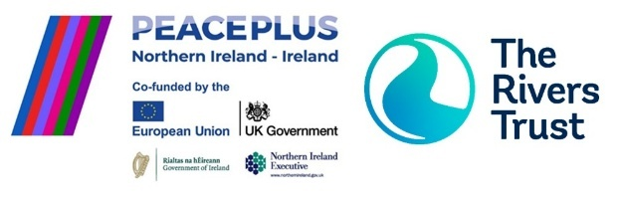

**Farm Advisor (Nature Based Solutions)**  
Join The Rivers Trust’s expanding All-Ireland team to support nature- and water-friendly farming in the Strule catchment. You’ll work directly with landowners to implement nature-based solutions that improve water quality and biodiversity, and deliver knowledge-sharing events, as part of the cross-border *Protecting Shared Waters* initiative, funded by PEACEPLUS and managed by SEUPB.

**Key Responsibilities**

* Design and Deliver On-Farm Nature-Based Solutions (NbS) in collaboration with famers.
* Conduct advisory farm visits and provide tailored guidance on sustainable practicesusing NbS.
* Coordinate Implementation and Contractor Oversight of the NbS installations.
* Lead Education and Knowledge Sharing Activities to promote sustainable farming.
* Support Monitoring and Evaluation.

**About You**  
You bring strong experience in environmental project delivery, particularly in agricultural settings, with a focus on nature-based solutions (NbS) and water quality improvement. You’re confident engaging with farmers, landowners, and diverse stakeholders, and skilled in delivering environmental education and knowledge-sharing events. Your understanding of water management, environmental policy, and farming systems enables you to design practical, impactful solutions. You’re a clear communicator, capable of building trust and driving behavioural change. Strong problem-solving, leadership, and remote teamwork skills are essential, along with the ability to manage projects independently and collaboratively.

**Please apply with your CV and cover letter via The Rivers Trust Careers Portal**<https://careers.theriverstrust.org/jobs/6291718-farm-advisor-nature-based-solutions>

**Apply by 12pm, 27 August 2025.**