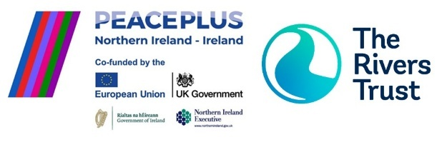

**Project Officer – Protecting Shared Waters Project**  
Join [The Rivers Trust](https://theriverstrust.org/) to lead community engagement and environmental action in the River Fane catchment (Counties Armagh/Monaghan), as part of the cross-border *Protecting Shared Waters* initiative, funded by PEACEPLUS and managed by SEUPB.

**Key Responsibilities**

* Stakeholder Engagement & Community Outreach.
* Co-design and develop Nature-based Solutions (NbS) projects with local stakeholders to protect and conserve water in the Fane catchment.
* Deliver an Ecological Community Outreach (ECO) Programme.
* Organise public events and knowledge-sharing between catchments.
* Collaborate with colleagues and uphold organisational policies and values.
* Monitoring of the outcomes of the NbS projects and educational actions.

**About You**  
You bring experience in environmental project delivery, community engagement, environmental education delivery and stakeholder collaboration. You understand NbS, water management, and environmental policy, and can communicate clearly with diverse audiences. Strong leadership, problem-solving, and remote teamwork skills are essential.

**Please apply with your CV and cover letter via The Rivers Trust Careers Portal**[**Project Officer (Protecting Shared Waters Project) - The Rivers Trust**](https://careers.theriverstrust.org/jobs/6293023-project-officer-protecting-shared-waters-project) **Apply by 12pm, 27 August 2025.**