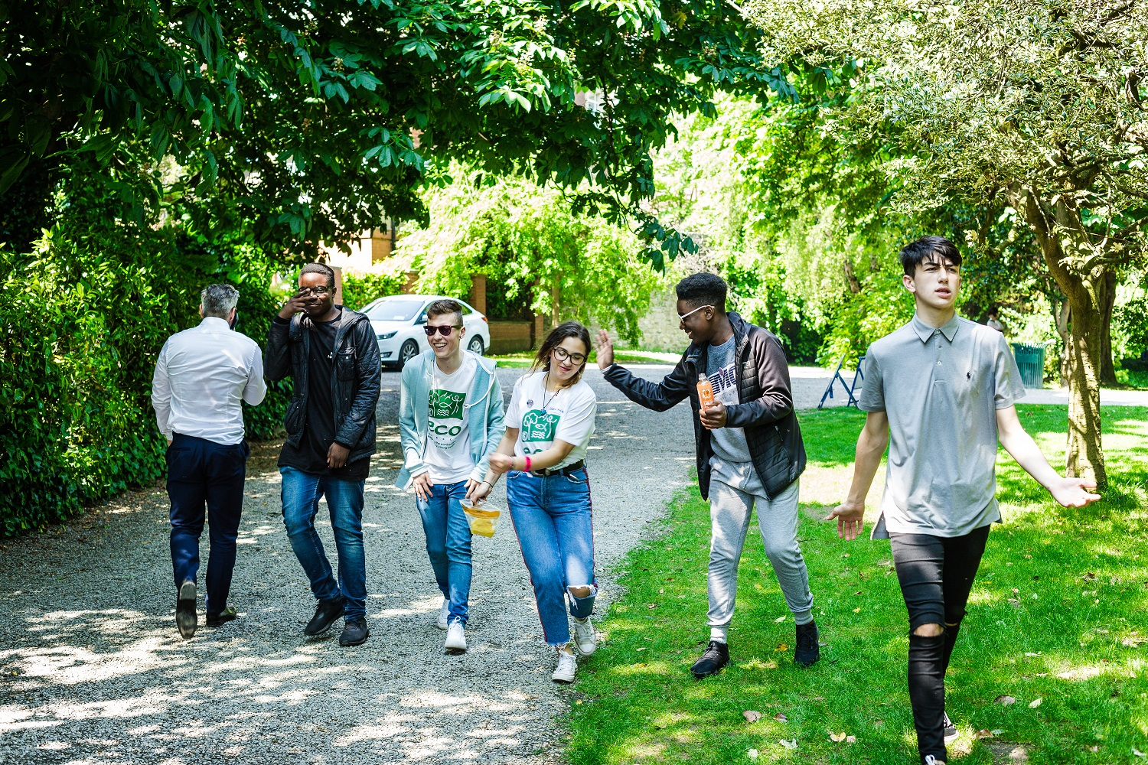

Candidate Information Pack
Youth Project Officer
ECO-UNESCO
2025

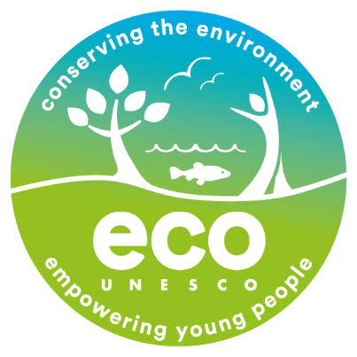

About ECO UNESCO
We are Ireland’s leading environmental education, training and youth organisation and a Quality and Qualifications Ireland training Centre (QQI), working with over 10,000 young people annually. We seek to raise awareness of environmental issues by channelling the passion, creativity and energy of young people into positive environmental action. ECO-UNESCO delivers a wide range of youth, education, and training programmes across Ireland to promote the personal development of young people through practical environmental projects. Through our range of programmes and services we inspire, educate, empower and support young people to act.

We work;
“Our vision is a sustainable world where young people are actively engaged in protecting the environment.”

- across the island of Ireland.
- to conserve the environment and empower young people.
- with young people in formal and nonformal settings, in secondary schools, youth services and communities across Ireland through our Young Environmentalist Awards, workshops, trainings or one of our affiliated ECO-UNESCO Clubs.
- and with partners in Europe and internationally.

Our Mission
Our mission is to protect the natural environment and empower young people by developing their knowledge, skills and confidence that channels their passion into positive and creative actions that helps create a sustainable planet.
We do this by;
- Raising awareness, understanding and knowledge of the natural environment among young people.
- Engaging, inspiring and empowering young people by facilitating their personal development and well-being through practical environmental projects, activities and skills development.
- Promoting the protection and conservation of the environment by empowering young people to lead in action-oriented environmental projects and activities and by promoting positive environmental behaviour.
- Advocating for environmental education, education for sustainable development, the natural environment and youth development.
- Promoting the ideals of UNESCO and working with like-minded organisations in Europe and globally.

Our Values
We have respect for young people, our participants, volunteers, employees and our stakeholders. In our work we have a passion for the environment and for our young people, with an acknowledgement that the natural environment plays an important role in all our lives and in the development and education of our young people. We value youth-led approaches, creativity and innovation, action-based learning and fun, as we work together to protect the environment and impact the lives of young people.
What we do
ECO-UNESCO’s programmes empower and support young people to take action to protect and conserve the natural environment.
- We take a youth-centred approach and promote learning for, about and in the environment
- We develop leadership skills, confidence, self-belief and self-esteem
- We provide opportunities for young people to feel socially engaged and make new friends
- We include young people’s views – they decide, they plan, they act and they engage their peers.
How we do it
Our work can be broken down into the following categories;

Environmental Youth Work
- Youth for Sustainable Development and Peer Education Programme
- Environmental youth events, activities, and workshops
- Clubs Programme
- ECO-Choices Health & Wellbeing
- International Youth Summit - #NoTimeToWaste
- Youth Climate Justice
Capacity Building and Training
- Green Youth Employment programmes
- Information and support provided to educators, youth leaders and young people
- Training including QQI accredited courses delivered to a wide audience
- Key Partner of the UNESCO Global Action Programme in Education for Sustainable Development
Awards
- Our annual Young Environmentalist Awards
Other Activities
- Development of environmental education resources
- ECO-Sustainability Award for organisations
- Representation and advocacy for environmental education and education for sustainable development (ESD)

Project Officer
This is a great opportunity to join an organisation that is protecting the natural environment and making a real difference to the lives of young people. If you have a passion for our natural environment, for youth development and are enthusiastic and motivated with a background in sustainability, then we would love to hear from you.

Contract: 2 years Fixed term (*subject to ongoing funding)
Probationary period: 6 months

About The Role
ECO-UNESCO seeks to employ a Project Officer for our youth programmes. You will assist with the delivery of our youth programmes including Youth for Sustainable Development (YSD); Youth Climate Justice and as youth programme needs arise and support on the recruitment of participants, setting up clubs, developing content, planning and direct workshop delivery.
This is a position of responsibility within ECO-UNESCO.

About ECO-UNESCOs Youth programmes
ECO-UNESCO delivers a wide range of youth programmes aimed at upskilling young people and empowering them to take action around sustainability issues.
Our youth programmes include - the Youth for Sustainable Development (YSD) programme is a non-formal youth club running in various locations around Ireland. The core of the programme is built around the delivery of a 12-week programme consisting of workshops, talks, events and games. Participants take a deep dive into the key sustainability issues facing our world and learn how interconnected all our problems and solutions really are. Throughout the 12-week programme, they are supported in undertaking an action project on an environmental topic of their choosing. We offer participants QQI Level 5 Accredited Training in Peer Education. This elective element teaches participants to be self-confident facilitators and passionate advocates for environmental sustainability. Our youth programmes also include the Youth Climate Justice programme aimed at building advocacy and leadership skills in young people.

Reporting to: | Youth for Sustainable Development and Climate Justice Programme Coordinator
Location: | ECO-UNESCO’S Headquarters at 9 Burgh Quay, Dublin 2 with occasional travel required.
Time commitment: | Full time (35 hours), Fixed Term Contract  Flexibility is required for this role as there is regular evening and weekend work involved.
Start Date: | Immediate
Salary: | Starting salary scale €32,000 - €34,000. Salary dependant on experience

Benefits
- 21 days annual leave per year which increases annually to a maximum of 25 days per year.
- An employer matched pension scheme is available after a qualifying period.
- An Employee Assistance Programme is available to all staff.
- Use of a Mobile Phone & Laptop
- Access to company car (when needed for work travel purposes)
- Bike to work & TaxSaver travel schemes
- Exam and study leave
Key Responsibilities

Development and Implementation
- Assisting the running of ECO-UNESCO’s Youth programmes including Youth for Sustainable Development; Youth Climate Justice and other programmes as the need arises.
- Promoting the establishment of ECO-UNESCO /YSD clubs regionally; assisting in volunteer recruitment, training, and support of clubs and liaising with partner organisations.
- Developing, promoting, and implementing training programmes in Education for Sustainable Development and Climate Justice for young people and youth leaders.
- Organising events including workshops and seminars.
- Assisting in the delivery and running of leader training course and in QQI accredited training courses including, project support, marking and administration where applicable.
- Researching and writing materials as needed
- Assisting in the implementation of the ECO-Sustainability Award for youth and community organisations.
- Developing and delivering identified outreach workshops
- Supporting in other ECO-UNESCO programmes as required
Promotion
- Promoting ECO-UNESCO’s programmes including YSD and Climate Justice through talks and presentations.
Other
- Updating participant information in Salesforce
- Completing Monitoring and Evaluation activities on a regular basis
- Undertaking any other such relevant duties as directed
- Assisting delivery of ECO-UNESCO’s other programmes as needed. Periodic assistance is required from all staff for our annual Young Environmentalist Awards, Youth Summits, and other large events.
- Representing ECO-UNESCO on relevant ESD and DE bodies.
- Providing regular reports to Management on educational activities.

This role description is not to be regarded as exclusive or exhaustive. It is intended as an outline indication of the areas of activity and can be amended. ECO-UNESCO reserves the right to reassign staff as appropriate and necessary.

Person Specification

Qualifications
- 3rd Level Qualification in a related field – in sustainable development/environmental studies or science/ecology/biology/ geography/ education (Essential)
- An education or youth work qualification (Desirable)
Experience
- At least 2 years work experience in direct work with young people (10-18); youth work, education and/or environmental education/sustainable development and /or in a similar youth scheme/programme (Essential)
- Experience in developing and delivering youth, education and training programmes (Essential)
- Demonstrable organization skills, having managed multiple priorities and adherence to deadlines (Essential)
- Budgetary management experience from initial planning through to end of project reporting. (Desirable)
- A strong interest in the environment, international development and working with young people (Essential)
- A full, clean driving license (Essential)
Knowledge and Skills
- Knowledge of the youth work sector and education system in Ireland (Essential)
- Knowledge of education for sustainable development/development education in Ireland (Essential)
- Knowledge of international development issues including climate justice (Essential)
- Excellent communications and interpersonal skills (Essential)
- Excellent report writing, analytical and computer skills (Essential)
- Ability to manage a complex workload (Essential)
- Ability to critically analyse data and make appropriate decisions (Desirable)
- Ability to work as part of a team (Essential)
Disposition
- Be a self-starter with a positive, can-do attitude
- Be a problem solver and creative
- Be dependable and flexible
- Be able to take direction
- Be committed to working as part of a team
- Be committed to the values and principles of ECO-UNESCO

ECO-UNESCO is an equal opportunities employer and all employees are expected to develop an understanding of and commitment to equal opportunities.

How to apply

Please send a copy of a completed Application Form to: recruitment@ecounesco.ie
Please mark in the subject line Employment Opportunities – YSD Project Officer (Private and Confidential)

Closing Date for Applications – 10th August 12noon

Successful applicants may be requested to prepare a short presentation during the selection process.

Applicants may be placed on a panel for positions that may arise in the future.

By completing and submitting this form you consent to ECO-UNESCO processing the personal data provided to assess this application for employment. No further processing of your data will occur beyond this purpose. ECO-UNESCO will retain this application for up to 12 months, after which it will be deleted.

Candidates, depending on the nature of the role, may be subject to Garda Vetting.

ECO-UNESCO

APPLICATION FOR EMPLOYMENT

Please complete all sections of the form. CVs are not accepted, and no application will be processed if the form is incomplete.

Position applied for: | YSD Project Officer
Where did you see the post advertised?

Personal Details
Title
Forename
Surname
Address
Please note, any successful candidate will have to be resident in Ireland upon taking up the position.
Phone
E-mail

Current or Last Employment
Position
Employer
Date from/to
Summary of achievements

Previous Employment (please add more rows if required)
Employer: | From: | To: | Position:
Summary of achievements:
Employer: | From: | To: | Position:
Summary of achievements:
Employer: | From: | To: | Position:
Summary of achievements:
Employer: | From: | To: | Position:
Summary of achievements:
Employer: | From: | To: | Position:
Summary of achievements:

Education and Qualifications
School/college /University… | From | To | Qualifications

Language Skills
 |  | Fluent | Moderate | Learning | None
ENGLISH (fluency essential) | Speaking
 | Writing
IRISH | Speaking
 | Writing
Add additional languages (with levels), or comments:

Relevant Experience
Detail how your skills and experience meet the requirements set out in the Job Description
3rd Level Qualification in a related field – in sustainable development/environmental studies or science / ecology/biology/ geography/ education | Please provide details…
At least 2 years work experience in direct work with young people (10-18); youth work, education and/or environmental education /sustainable development and /or in a similar youth scheme/programme | Please provide details…
Experience in developing and delivering youth, education and training programmes | Please provide details…
Demonstrable organisation skills, having managed multiple priorities and adherence to deadlines | Please provide details…
Knowledge of the youth work sector and education system in Ireland | Please provide details…
Relevant interests | Please provide details…

Statement in support of your application
Please outline your motivation for applying for this post.

Additional Questions
If successful, what is the earliest date that you could start the job?
Do you hold a current, full, and clean Driving License valid in the Republic of Ireland? |  |  | Yes / No  (Desirable but not essential)
Is there anything else you feel we need to know to support you in your application?
References
Please provide details of two referees, including your present or most recent employer. We will not contact your referees until we have contacted you and received your consent. Please ensure you have your referee’s permission to share their contact information.
1 | Name
 | Position
 | Address
 | Tel. No.
 | E-mail

2 | Name
 | Position
 | Address
 | Tel. No.
 | E-mail

Declaration
I declare that the statements made by me in this application are true and that the accuracy thereof shall be a condition of any contract of employment offered to me by ECO-UNESCO:

Signature of Applicant
Date

Please e-mail your completed form to recruitment@ecounesco.ie with Employment Opportunities – YSD Project Officer (Private and Confidential) in the subject line.

Closing Date for Applications – 10th August
Interview Date – provisionally first interviews scheduled for week commencing 11th August 2025

