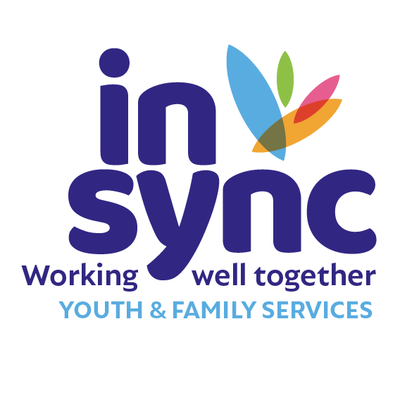

**JOB DESCRIPTION: DIRECTOR OF SERVICES (Youth Work Services)**

In Sync Youth & Family Services provides therapeutic and youth work services to young people, children and families in Kildare and West Wicklow and advocates and collaborates for improved access to services and better outcomes for young people, children and families. In Sync is committed to the provision of quality youth & family services through an integrated multi-disciplinary approach.

Our Vision is of a more inclusive, fair, equal, safe society where young people, children and families are supported and valued equally.

In Sync operates in 13 locations across Kildare & West Wicklow and employs up to 85 people from a variety of professions across these locations.

**Job Title:** Director of Services (Youth Work Services)

**Function:**  The Director of Services (Youth Work Services) is a member of the Senior Management Team, with shared responsibility for the day-to-day operations of In Sync, and with direct responsibility for the management and support of the In Sync Youth Work Services.

**Location:** Office base is located in Naas, Co. Kildare. In Sync operates a hybrid working model with a combination of remote and in-person working.

Regular travel in line with requirements of the organisation is required. Travel costs are reimbursed in line with company policy.

**Reporting to:** CEO

**Direct Reports:** Youth Work Coordinators x 2

**Contract:** An initial 12 month fixed-term contract, renewable subject to funding.

**Probationary Period:** A probationary period of 6 months.

**Working Hours:** 38 hours per week.

In Sync operates a Time Off In Lieu (TOIL) system for hours worked over

the contracted hours.

**Benefits:** 28 days annual leave per annum

PRSA scheme on completion of probation, with a 5% employer contribution under the conditions of the company policy.

Flexible, family-friendly policies and procedures in place.

**Key Strategic Responsibilities:**

**Lead Role:**

* Lead the strategic development of In Sync Youth Work including review of services, growth and innovation, policy, and practice.

**Shared Role:**

* Support the development, delivery, and review of the strategic plan and associated implementation plans.
* Represent and promote the organisation at a regional and local level to various bodies, networks, and fora with a view to promoting its services, exchanging ideas and accomplishing objectives.
* Build and maintain collaborative and productive relationships with key stakeholders at a local and regional level representing the interests of In Sync and of young people, children and families in Kildare & West Wicklow.
* Support the development of an organisational structure and systems to support the achievement of In Sync Strategic outcomes.
* Support the development and implementation of In Sync Communications Strategy that ensures effective internal communication with the Board, and with staff and volunteers, and at the same time grows the wider awareness of In Sync across the region through engagement with all media and improves access among the target population of young people, children and families.
* Support the development and implementation of a risk management strategy as part of the Senior Management Team in conjunction with the Board so as to be cognisant of and responsive to the broader environment in order to identify opportunities and/or threats for In Sync.

**Key Management Responsibilities:**

**Lead Role:**

* To oversee the day-to-day operations and development of In Sync Youth Work Services.
* Directly manage, supervise, and support the Youth Work Coordinators.
* Lead the development and implementation of a performance management framework that ensures the effective management, supervision and support of all staff and volunteers within In Sync in order to maintain a high quality of service with and for young people, children and families.
* Lead and coordinate the systematic development, implementation and review of appropriate policies and procedures for the organisation, including HR, Governance, Compliance, Health & Safety, and Data Protection, as well as those directly related to youth work.
* Coordinate Data Protection practice to ensure that In Sync processes the personal data of its staff, volunteers, children, young people, families, providers or any other individuals (also referred to as data subjects) in compliance with the applicable data protection rules.
* Coordinate Health and Safety functions to ensure the organisations, staff and volunteers and all premises and facilities are compliant with Health & Safety legislation.

**Shared Role:**

* Ensure the Board can be effective in their role through regular reports, advice, and recommendations, so that the Board can take whatever decisions might be needed.Build and maintain a positive, progressive, and professional culture with In Sync for the benefit of staff, volunteers and the people we work with.
* Ensure compliance with all relevant laws, regulations, and funder accountability measures.
* Review operations on an ongoing basis to evaluate performance of the youth work services and the staff teams in meeting objectives, and to determine areas of potential opportunity and areas of potential risk.
* Support the implementation of Child Safeguarding policies and procedures across the youth work projects, including taking on the role of Deputy DLP and working closely with DLP.

**Key Development Responsibilities:**

**Lead Role:**

* Develop opportunities and strategies for the growth and development of youth services in Co. Kildare & West Wicklow.

**Shared Role:**

* Provide opportunities for the participation of young people in decision making at all levels of the organisation.
* Ensure In Sync works closely with the local communities, statutory agencies, and community organisations to develop a range of appropriate programmes and services in a coordinated integrated manner to meet the identified needs of young people, children and families.
* Participate in the development and implementation of an In Sync integrated service model where young people, children and families have clear pathways to move through and across our services.
* Implement and monitor a system for the evaluation of the effectiveness of our youth work.
* Support a culture of excellence in our practice to ensure quality provision and clear integration of all our work against a broad theoretical framework.
* Develop and maintain a culture that promotes research, policy, and practice development within the organisation.
* To undertake any duties as may be assigned from time to time by the Board of In Sync.