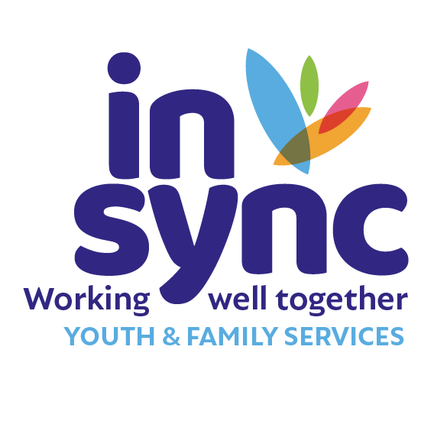

|  |
| --- |
| **Employment Application Form** |

|  |  |
| --- | --- |
| **Application for the Post of:** |  |

|  |  |
| --- | --- |
| **Surname:** |  |
| **First Names:** |  |
| **Address:** |  |
| **Phone:** |  |
| **Email:** |  |

|  |  |  |  |
| --- | --- | --- | --- |
| **EDUCATION & TRAINING** | | | |
| **Academic and/or Professional qualifications**  **(Please start with your most recent qualification)** | | | |
| **Dates Attended** | **Institution** | **Course Title & Content** | **Qualification Attained** |
|  |  |  |  |
|  |  |  |  |
|  |  |  |  |
|  |  |  |  |
|  |  |  |  |

|  |  |  |  |  |  |  |
| --- | --- | --- | --- | --- | --- | --- |
| **Continuous Professional Development**  **(Please include any relevant certified short courses and in-service training completed)** | | | | | | |
| **Dates Attended** | **Awarding body** | | | **Course title & Content** | | **Qualification Attained** |
|  |  | | |  | |  |
|  |  | | |  | |  |
|  |  | | |  | |  |
|  |  | | |  | |  |
|  |  | | |  | |  |
|  |  | | |  | |  |
|  |  | | |  | |  |
|  |  | | |  | |  |
| **Work Experience**  **(Start with most recent employer)** | | | | | | |
| **Dates**  **(from – to)** | | **Employer** | **Job Title** | | **Key Duties & Responsibilities**  **(Include reason for leaving)** | |
|  | |  |  | |  | |
|  | |  |  | |  | |
|  | |  |  | |  | |
|  | |  |  | |  | |
|  | |  |  | |  | |
|  | |  |  | |  | |
|  | |  |  | |  | |

|  |  |  |  |  |  |  |  |  |
| --- | --- | --- | --- | --- | --- | --- | --- | --- |
| **Additional Information** | | | | | | | | |
|  | | | **Yes** | | **No** | | **Please include further information/explanation if required.** | |
| Is there anything in your personal or professional background that would make you unsuitable to work with children and young people? | | |  | |  | |  | |
| Does in sync Youth & Family Services have your permission to present you for Garda Vetting? | | |  | |  | |  | |
| Are there any restrictions on your right to work in this country? | | |  | |  | |  | |
| Do you hold a current full Driving Licence? | | |  | |  | |  | |
| Current Salary (including bonuses etc.): | | | | | | | | |
| Period of notice required from current employer: | | | | | | | | |
| **References** | | | | | | | | |
| Please give details of three individuals whom we can contact for references.  (*No approach will be made to your present employers without your prior permission*.) | | | | | | | | |
|  | **Name** | **Organisation** | | **Address** | | | | **Phone** |
| **1.** |  |  | |  | | | |  |
| **2.** |  |  | |  | | | |  |
| **3.** |  |  | |  | | | |  |
| **Declaration** | | | | | | | | |
| I confirm that the above information is correct to the best of my knowledge. I understand that any omissions or misrepresentation of information on this application form may in the event of my obtaining employment result in disciplinary action up to and including dismissal. | | | | | | | | |
| **Applicants Name:** | | | | | | **Date:** | | |

**Equal Opportunity:**in sync Youth & Family Services ***is an equal opportunity employer in line with the provisions of its Equality Policy.***

**Data Protection/GDPR:**in sync Youth & Family Services ***will use the information in this application solely for the purposes of the recruitment process. It will be retained for a minimum of 12 months, stored and disposed of confidentially as per our Data Protection Policy & Procedures.***