
Candidate Information Pack
Head of Fundraising and Business Development
ECO-UNESCO
May 2025

Readvertisement
About ECO-UNESCO
We are a leading environmental education and youth organisation working to channel the passion, creativity, and energy of young people into positive environmental action. Through our range of programmes and services we engage, educate, inspire, empower, and support young people to act.

We work
“Our vision is a sustainable world where young people are actively engaged in protecting the environment.”

- across the island of Ireland
- to conserve the environment and empower young people.
- with young people in formal and non-formal education settings, in secondary schools, youth services
- with communities across Ireland through our Young Environmentalist Awards, workshops, trainings or affiliated ECO-UNESCO Clubs and groups.
- with partners in Europe and internationally.
Our Mission
Our mission is to protect the natural environment and empower young people by developing their knowledge, skills and confidence that channels their passion into positive and creative actions that helps create a sustainable planet. We do this by:
- Raising awareness, understanding and knowledge of the natural environment among young people.
- Engaging, inspiring and empowering young people by facilitating their personal development and well-being through practical environmental projects, activities and skills development.
- Promoting the protection and conservation of the environment by empowering young people to lead in action oriented environmental projects and activities and by promoting positive and environmental behaviour.
- Advocating for environmental education, education for sustainable development, the natural environment and youth development.
- Promoting the ideals of UNESCO and working with likeminded organisations in Europe and globally.
Our Values
We have respect for young people, our participants, volunteers, employees, and our stakeholders. In our work we have a passion for the environment and for our young people, and an acknowledgement that the natural environment plays an important role in all our lives and in the development and education of our young people. We value youth-led approaches, creativity and innovation, action based learning, and fun as we work together to protect the environment and impact the lives of young people.

What we do
ECO-UNESCO’s programmes empower and support young people to take action to protect and conserve the natural environment.
- Through education for sustainable development and environmental education we build knowledge and skills in young people and explore attitudes and values.
- We take a youth centred approach and promote learning for, about and in the environment
- We develop leadership skills, confidence, self-belief, and self-esteem
- We provide an opportunity for young people to feel socially engaged and make new friends
- We include young people’s views – they decide, they plan, they act, and they engage their peers.
How we do it
Our work can be broken down into the following categories
Environmental Youth Work
- Youth for Sustainable Development and Peer Education Programme
- Environmental youth events, activities, and workshops
- ECO-Youth Choices Health & Wellbeing
- Youth Climate Justice
- International Youth Summits
- Clubs Programme
Capacity Building and Training
- Green Youth Employment programmes
- Information and support provided to educators, youth leaders and young people
- Training including QQI accredited courses delivered to a wide audience
- Key Partner of the UNESCO Global Action Programme in Education for Sustainable Development
Awards
- The Annual Young Environmentalist Awards
Other Activities
- Development of environmental education resources
- ECO-Sustainability Award for organisations
- Representation and advocacy for environmental education and education for sustainable development (ESD)

Approach to Fundraising

ECO-UNESCO has a diverse range of funding sources with more than 75% of funding coming from the government sector. The organisation has a strong track record in attracting grant income from a range of sources including the Department of Children and Youth Affairs, the Department of Communications, Climate Action and Environment, Irish Aid, Pobal, EPA, Local Authorities, EU funding. Grant income sources require ongoing application and reporting and there is a high level of administration associated.

Currently within the organisation a number of staff members are engaged in grant writing including programme staff, the Communications Officer, the Operations Manager and the National Director.
ECO-UNESCO’s plan is to increase its funding base as outlined in our Fundraising strategy. It wants to specifically diversify its funding base and to increase its unrestricted funding. Its strategy is to increase corporate sponsorship, develop its supporter programme, build philanthropic funding, grow donations, and grow self-generated income.

The Role
ECO-UNESCO is seeking to recruit a highly experienced fundraising professional as the Head of Fundraising and Business Development. Reporting to the National Director (CEO) and working alongside the Communications and Marketing Coordinator and senior management team, the Head of Fundraising and Business Development will be responsible for increasing income with a focus on sources outside of existing government funding and will therefore be expected to generate substantial support in this area. This would include funding from corporate sponsors, philanthropic sources and foundations, donor programmes, the development and delivery of a supporter programme and donations. The role will also be expected to support the business development of ECO-UNESCO’s programmes and services and the generation of income from services including workshops and trainings.
The Head of Fundraising and Business Development will be expected to develop a specialist fundraising team as income targets are achieved. As the role reports to the National Director, there is limited scope to be promoted but there will be opportunities for growth through education/training/CPD.

Job Purpose:

The purpose of this senior position is to drive ECO-UNESCO’s fundraising from sources outside of government funding, covering the following:

- Corporate giving
- Fundraising
- Trusts and Foundations
- Philanthropy & legacy donations
- Supporter programme
- eCommerce, digital and online communications strategy
- Brand management

The position will:

- Take the lead on new growth, outside existing Government supported programmes, harnessing new and emerging sources of funding.
- Plan a pipeline of suitable Funders / Purchasers / Investors, expanding the current corporate sponsorship donor base, targeting corporate ESG initiatives and identifying other growth-related opportunities.
- Develop and deliver ECO-UNESCO’s Fundraising strategy
- Develop a coherent ECO-UNESCO service offering under a unified brand, ensuring alignment of CSR goals of potential funders with the mission, vision & values of ECO-UNESCO.
- Develop ECO-UNESCO’s Digital & eCommerce strategy
- Launch fundraising campaigns and programmes
- Enhance the promotion of existing Programmes to cross-sell to non-Governmental and EU Funders
- Build a strong network of supporters for ECO-UNESCO
- Support the business development of ECO-UNESCO’s programmes and services and the generation of income from services including workshops and trainings.

Key Responsibilities:
Thought Leadership:

- Provide strategic thought leadership around fundraising and business development to the new Strategic Plan 2025.
- Lead on the achievement of key strategic priorities.
- Devise appropriate structures, approaches and targets to secure funding.
- Develop an annual plan with monthly milestones, including pipeline development and income targets.

Relationships:

- Work closely with the National Director, Operations Manager, Head of Finance and Corporate Services, Board, private equity, large corporates, lawyers, banks, business partners and other organisations with whom ECO-UNESCO collaborates.
- Develop a matrix of responsibility to work within existing ECO-UNESCO functions, including Communications, social media and Brand Management.
- Manage on-going relationships with partners / funders / supporters / donors outside of Governmental organisations.
- Attend meetings with potential sponsors and donors, manage fundraising events, make tailored presentations, and prepare Information Memoranda, developing our contact base of potential funders.
- Develop relationships with the public to ensure growing levels of financial and non-financial support.

Financial Reporting and Evaluation:

- Perform due diligence checks, review and clarify contractual transactions and fundraising mandates, ensuring appropriate paperwork is in place.
- Prepare funder reports to demonstrate how incoming funding is returning a benefit to the Funder and collaborating with Finance Officer to collate relevant information.
- In conjunction with the Head of Finance, prepare and maintain cradle to grave financial modelling, rolling income and expenditure run rate / forecast.
- Record, monitor and report income generation progress to the National Director and Board.

Key Requirements:

Qualifications/ Experience

- 5+ years of proven commercial experience, working at a senior level in a fundraising role.
- Experience and knowledge of the charity sector.
- Experience of raising substantial funding within a reasonable timeframe from corporate clients, including developing new leads and sources outside of government funding.
- Experience managing a varied workload.
- Experience of liaising with a wide range of stakeholders in the corporate sector.
- Experience communicating with stakeholders at all levels of an organisation.
- Experience applying for funding and reporting on outcomes.
- Self-motivated, self-managed, experienced salesperson.

Knowledge/Skills

- Proven ability to influence and motivate individuals at all levels.
- Excellent written & verbal communication skills.
- Excellent research ability.
- A proactive, solution focused outlook.
- Ability to identify roadblocks and develop creative and timely solution to overcome them.
- Personal values are in line with those of ECO-UNESCO.
- Excellent IT skills, specifically Office 365, Salesforce or another CRM system desired.

Note: ECO-UNESCO has an Equal Opportunities policy and all employees are expected to develop an understanding of and commitment to equal opportunities.

The person who will succeed in this role
The successful candidate will be a highly experienced fundraiser who is a creative, innovative, enthusiastic self-starter, strategic thinker, and planner with a proactive, solution-focused outlook. They will have strong communication and organisation skills and the ability to recognise where they can add value to a situation. They will have confidence in working with a wide variety of stakeholders, donors, supporters and service users, the ability and willingness to be hands-on and will be very personable and cooperative.
ECO-UNESCO, is young person centred and our programmes and initiatives on the environment and social justice are engaging, empowering, educational and fun. Our creativity positions us at the cutting edge of our sector and the feedback received from people who participate in their programmes is a great source of motivation. Anyone who joins, should have personal values that are in-line with those of ECO-UNESCO.

Key objectives for the Role
The primary objective of the role is to raise unrestricted funds for the organisation through a range of channels including:
- Corporate Sponsorship
- Philanthropy & Legacy Donations
- Foundations and Grants
- Fundraising events
- Supporter Programme
- eCommerce, Digital and Online communications strategy
- Brand Management
- Business development opportunities
- Generating income from service delivery

Targets
• Where a service is provided, return on investment is to be 4 – 5 times the cost of the service.
• The initial target for the Head of Fundraising will be to generate four times their annual salary within 18 months and a proposed €2m of unrestricted income within 3 years.

A typical day
The Head of Fundraising and Business Development will focus on the development of a fundraising strategy and implementation plan. It is envisaged the role would include grant writing and proposals for philanthropic sources and foundations; making pitches to proposals corporates to secure corporate sponsorship; grant writing and reporting; meetings; securing funding through the supporter programme and leading on-line fundraising

Key information about this role
- This is a full-time, permanent position
- This role will be based at 9 Burgh Quay, Dublin 2 with options for hybrid working arrangement
- The salary for this position is in the range of €60,000 – €66,000 (starting salary will depend on experience)
- The annual leave entitlement is 30 days
- Pension – employer matched contribution up to a maximum of 5% after a specific time with the organisation
- This is a full-time role over 35 hours per week. Evening and weekend work will be required.
- The position is based at ECO-UNESCO’s Offices at 9 Burgh Quay, Dublin 2 with hybrid working options
- An Employee Assistance Programme is available to all staff.

How to apply

Please complete the Application form (below) and send with a cover letter to recruitment@ecounesco.ie or return it by post to:

Employment Opportunities

Head of Fundraising and Business Development

ECO-UNESCO

9 Burgh Quay

Dublin 2

Ireland

Please note: This is a readvertisement. If you applied for this position and wish to be considered please let us know however you do not need to complete another application form.
The closing date for applications is Midnight 15th June 2025
Applications will be assessed on an ongoing basis.
Interviews will be competency based and seek to better understand your background, skills, and experience.
2nd round interviews may be conducted where the panel feel there is a need.
Candidates will be subject to Garda Vetting
Candidates may be placed on a panel for suitable future positions that may become available

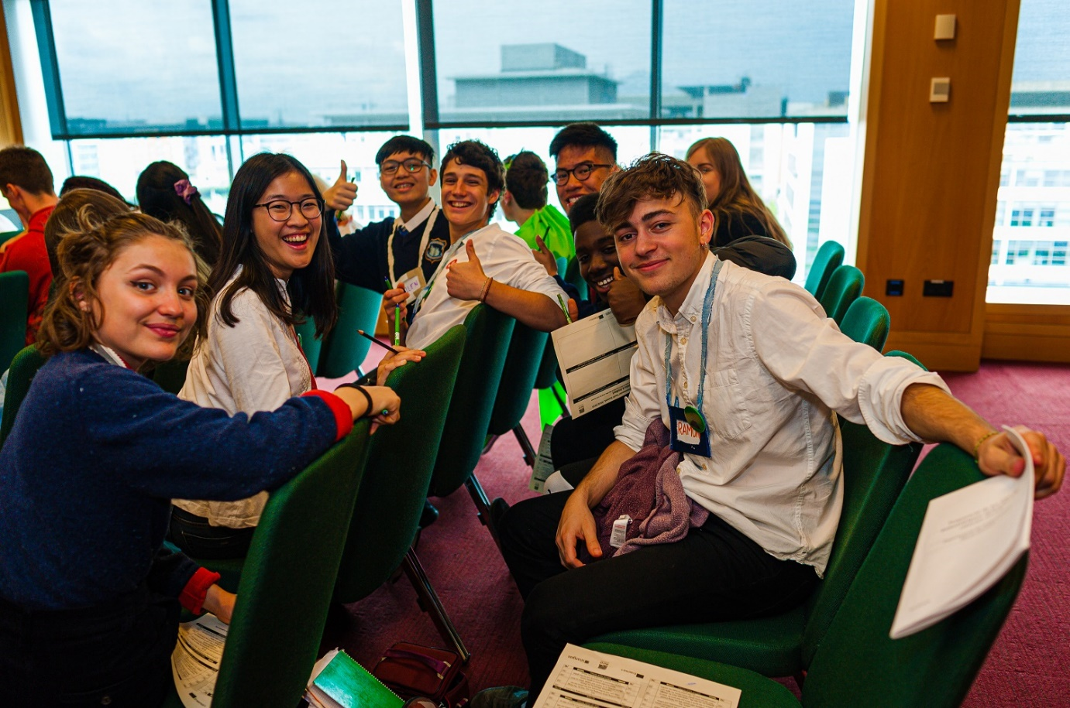

ECO-UNESCO

APPLICATION FOR EMPLOYMENT

Please complete all sections of the form.
Position applied for:
Where did you see the post advertised?

APPLICATION FOR EMPLOYMENT

Please complete all sections of the form.
Position applied for:
Where did you see the post advertised?

Personal Details
Title
Surname
Forename(s)
Address
Phone
E-mail

Current or Last Employment
Position
Employer
Date from/to
Summary of achievements

Previous Employment (please add more rows if required)
Employer: | From: | To: | Position:
Summary of achievements:

Employer: | From: | To: | Position:
Summary of achievements:

Employer: | From: | To: | Position:
Summary of achievements:

Employer: | From: | To: | Position:
Summary of achievements:

Education and Qualifications
School / college / university… | From | To | Qualifications

Language Skills
 |  | Fluent | Moderate | Learning | None
ENGLISH | Speaking
 | Writing
IRISH | Speaking
 | Writing
Add additional languages (with levels), or comments:

Experience & Skills
Please detail how your skills and experience meet the requirements set out in the job description. Before completing this section, please read the job description for this post carefully. For each item in the person specification (except formal qualifications already listed), you should give examples from your past employment, interests, voluntary work or life experiences to demonstrate how you meet the requirements of the post.

Statement in support of your application
Please outline motivations for wanting this post.

Additional Questions
If successful, what is the earliest date that you could start the job?
Do you hold a current, full and clean Driving License valid in the Republic of Ireland? |  |  |  |  | Yes / No  (desirable but not essential)
References
Please provide details of two referees, including your present or most recent employer. We will not contact your referees until we have informed you and received your consent. Please ensure you have your referee’s permission to share their contact information.
1 | Name
 | Position
 | Address
 | Tel. No.
 | E-mail
2 |  | Name
 |  | Position
 |  | Address
 |  | Tel. No.
 |  | E-mail

Declaration
I declare that the statements made by me in this application are true and that the accuracy thereof shall be a condition of any contract of employment offered to me by ECO-UNESCO:

Signature of Applicant
Date

Please e-mail your completed form to recruitment@ecounesco.ie or return it by post to:

Employment Opportunities

(Operations and development Manager)

ECO-UNESCO

9 Burgh Quay

Dublin 2

Ireland

Closing date for applications is Midnight 15th June 2025

