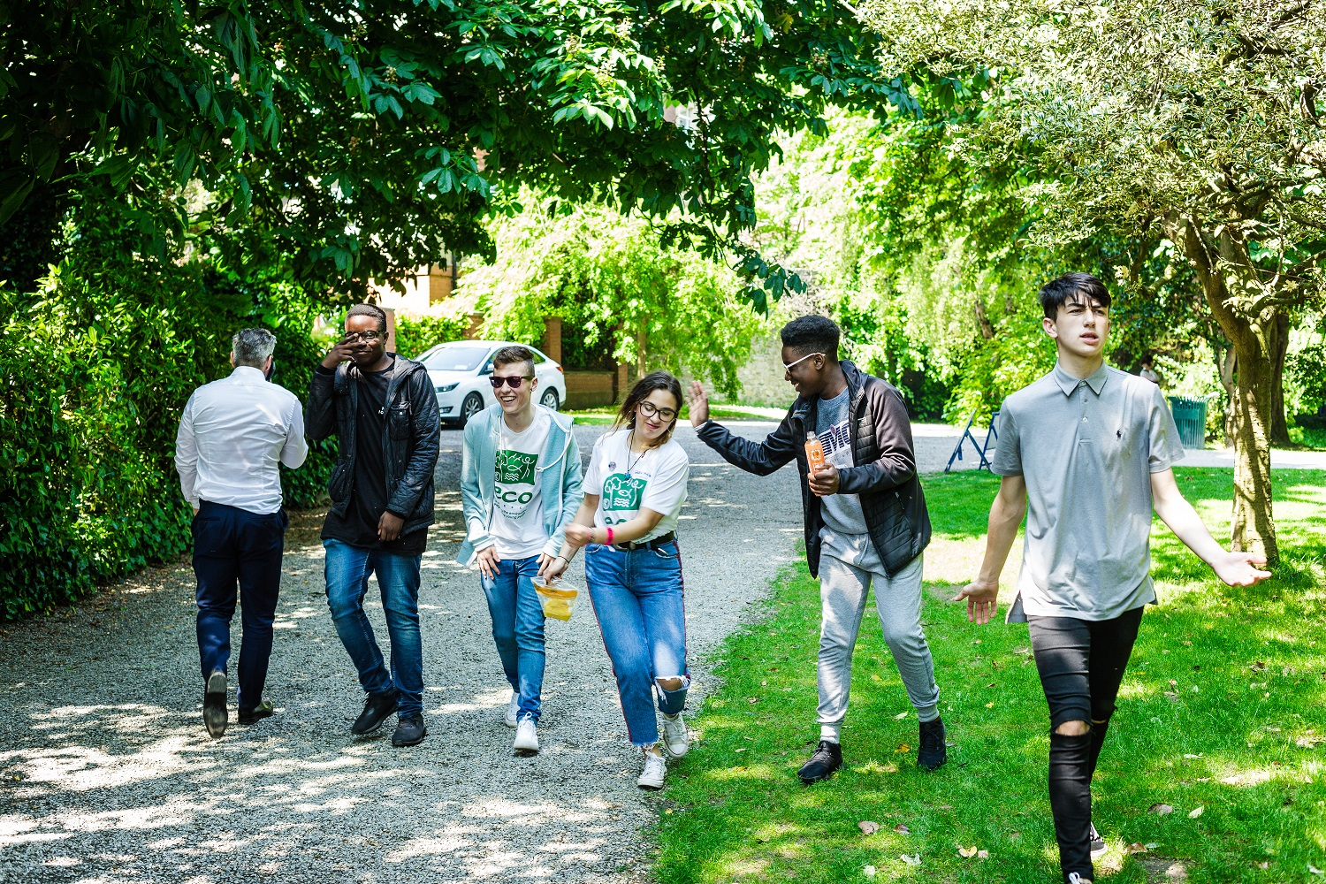

Candidate Information Pack
Marketing & Communications Manager
ECO-UNESCO
2024

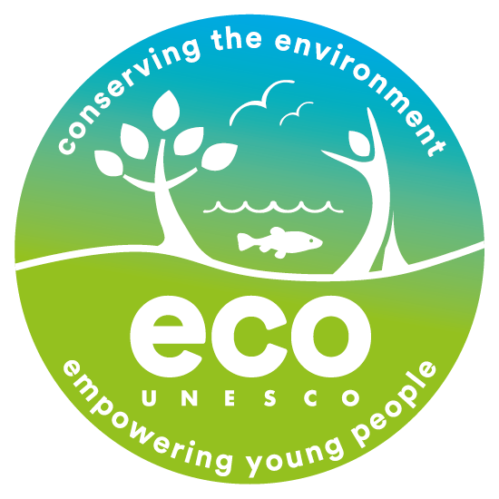

About ECO UNESCO
We are Ireland’s leading environmental education, training and youth organisation and a Quality and Qualifications Ireland training Centre (QQI), working with over 10,000 young people annually. We seek to raise awareness of environmental issues by channelling the passion, creativity and energy of young people into positive environmental action. ECO-UNESCO delivers a wide range of youth, education, and training programmes across Ireland to promote the personal development of young people through practical environmental projects. Through our range of programmes and services we inspire, educate, empower and support young people to act.

We work;
“Our vision is a sustainable world where young people are actively engaged in protecting the environment.”

- across the island of Ireland.
- to conserve the environment and empower young people.
- with young people in formal and nonformal settings, in secondary schools, youth services and communities across Ireland through our Young Environmentalist Awards, workshops, trainings or one of our affiliated ECO-UNESCO Clubs.
- and with partners in Europe and internationally.

Our Mission
Our mission is to protect the natural environment and empower young people by developing their knowledge, skills and confidence that channels their passion into positive and creative actions that helps create a sustainable planet.
We do this by;
- Raising awareness, understanding and knowledge of the natural environment among young people.
- Engaging, inspiring and empowering young people by facilitating their personal development and well-being through practical environmental projects, activities and skills development.
- Promoting the protection and conservation of the environment by empowering young people to lead in action-oriented environmental projects and activities and by promoting positive environmental behaviour.
- Advocating for environmental education, education for sustainable development, the natural environment and youth development.
- Promoting the ideals of UNESCO and working with like-minded organisations in Europe and globally.

Our Values
We have respect for young people, our participants, volunteers, employees and our stakeholders. In our work we have a passion for the environment and for our young people, with an acknowledgement that the natural environment plays an important role in all our lives and in the development and education of our young people. We value youth-led approaches, creativity and innovation, action-based learning and fun, as we work together to protect the environment and impact the lives of young people.
What we do
ECO-UNESCO’s programmes empower and support young people to take action to protect and conserve the natural environment.
- We take a youth-centred approach and promote learning for, about and in the environment
- We develop leadership skills, confidence, self-belief and self-esteem
- We provide opportunities for young people to feel socially engaged and make new friends
- We include young people’s views – they decide, they plan, they act and they engage their peers.
How we do it
Our work can be broken down into the following categories;

Environmental Youth Work
- Youth for Sustainable Development and Peer Education Programme
- Environmental youth events, activities, and workshops
- Clubs Programme
- ECO-Choices Health & Wellbeing
- International Youth Summit - #NoTimeToWaste
- Youth Climate Justice
Capacity Building and Training
- Green Youth Employment programmes
- Information and support provided to educators, youth leaders and young people
- Training including QQI accredited courses delivered to a wide audience
- Key Partner of the UNESCO Global Action Programme in Education for Sustainable Development
Awards
- Our Annual Young Environmentalist Awards
Other Activities
- Development of environmental education resources
- ECO-Sustainability Award for organisations
- Representation and advocacy for environmental education and education for sustainable development (ESD)

Marketing & Communications Manager
We are seeking to recruit a Marketing & Communications Manager for a one-year contract. This is a great opportunity to join an organisation that is making a real difference to the lives of young people and our environment. If you have a passion for youth work and environmental education, are enthusiastic and motivated, with great people management and organisation skills, then we would love to hear from you.

Contract: Fixed Term – 1 year

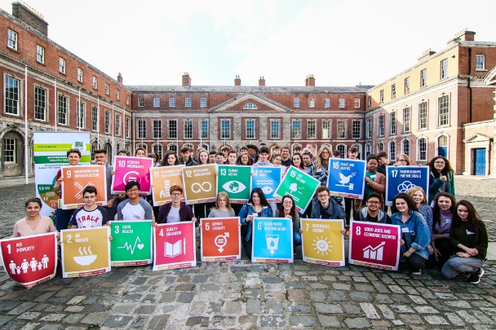
About The Role
This is a new position of responsibility within ECO-UNESCO. As Marketing and Communications Manager, you will be responsible for developing and managing ECO-UNESCO's marketing and communications strategy with the objective of building public awareness of ECO-UNESCO, our range of programmes and manage our engagement with our young people, educators, funders and various audiences.
This is a position of responsibility within the organisation, and applicants should be able to demonstrate the ability to take on such responsibility.

Reporting to: | Head of Fundraising and the National Director
Location: | ECO-UNESCO’S Headquarters at 9 Burgh Quay, Dublin 2, D02 FD85 – hybrid working options with occasional nationwide travel required.
Time commitment: | Part-time 4 days per week, 28 hours per week  Flexibility is required for occasional evening and weekend work.  Fixed Term Contract
Start Date: | Immediate
Salary: | From €41,355 - €45,950 depending on experience (pro-rata for 28-hour contract)

Benefits
- 21 days annual leave per year pro rata which increases annually to a maximum of 25 days per year
- An employer-matched pension scheme is available after a qualifying period
- An Employee Assistance Programme is available to all staff
- Use of a Mobile Phone & Laptop
- Access to company car (when needed for work travel purposes)
- Bike to work & TaxSaver travel schemes
- Exam and study leave
Key Responsibilities: Job Description
The Marketing and Communications Manager will broadly be responsible for the following:

- Develop an ambitious marketing and communications strategy for the organisation with ambitious KPIs and targets. This strategy will ensure that ECO-UNESCO’s wide range of communications channels continue to grow the reach and scale of our impact, amplify youth voices on key environmental issues, and drive participation and engagement from young people, educators, trainers, schools, youth organisations, donors, with our programmes, events and projects.
- Be responsible for line managing the communications staff member.
- Collaborate with the ECO-UNESCO team to develop and implement communications plans that promote our range of youth programmes and services, our education and training, and supporter and donation programmes to key stakeholders. This will include annual promotional drives, annual mailshots, email marketing; Google Ads, attendance at external events; advertisements with a view to increasing our organisational reach amongst key audiences.
- Oversee ensuring a consistent brand and voice in all ECO-UNESCO’s communications and managing brand guidelines, report templates and other visual representations of ECO-UNESCO’s work to reach wider audiences.
- Ensure a cohesive social media strategy, overseeing ECO-UNESCO’s social media presence to grow ECO-UNESCO’s reach on our social media platforms and manage effective reporting.
- Oversee the ECO-UNESCO website, to ensure all information is up to date; monitor its effectiveness and drive growth in visitors to the site including in e-commerce and the ECO-Academy (ECO-UNESCO’s online learning hub).
- Oversee all print and electronic materials, including, for example, mailshots and newsletters.
- Manage all publications, marketing and promotional leaflets including ECO-UNESCO’s Annual Report; the annual prospectus; the annual newsletter and other publications as required.
- Ensure effective strategy around ECO-UNESCO attendance at events.
- Work with management to identify media opportunities and implement campaigns around key programmes and environmental issues. Oversee ECO-UNESCO's PR work including liaising with and creating media contacts; writing press releases & preparing press briefings; organising Photocalls; reviewing media monitoring; liaising with external PR contractors.
- Support the organisation’s fundraising campaigns and donations appeals including creating packages for potential sponsors, developing fundraising appeals, supporting the growth and development of the organisation's supporter programme.
- Measure and report on the effectiveness of marketing and communications activities and engagement levels, in line with KPIs and targets.

Other
- Undertake any other such relevant duties as may from time to time arise
- Maintain clear records of all contacts and activities
- Deal with general queries from the general public and members

This role description is not to be regarded as exclusive or exhaustive. It is intended as an outline indication of the areas of activity and can be amended. ECO-UNESCO reserves the right to reassign staff as appropriate and necessary.

Person Specification

Qualifications
- 3rd Level Qualification in a related field or equivalent industry experience (Essential)
Experience
- At least 5 years experience in marketing, communications, event management, developing online content (Essential)
- Experience of working in information provision and with the media (Essential)
- Experience with online marketing tools, social media platforms and publishing software (Essential)
- Experience in event management (Desirable)
- Experience working with a young target group (i.e. second level and youth work sectors) (Desirable)

Knowledge and Skills
- Meticulous attention to detail and excellent time/task management skills (Essential)
- Excellent organisational skills (Essential)
- Excellent communication and interpersonal skills (Essential)
- Excellent writing, analytical and computer skills (Essential)
- Ability to work to tight deadlines and under pressure (Essential)
- Ability to respond adeptly to rapidly changing priorities and successfully manage multiple initiatives at once (Essential)
- Working knowledge of Salesforce or a similar Customer Relationship Management system (Desirable)
- Working knowledge of graphic design packages/methodologies (Desirable)
- Knowledge of the youth work sector and Irish education sector in Ireland would be an advantage (Desirable)

Disposition
- Demonstrated interest in ECO-UNESCO’s mission with a commitment to the values and principles of ECO-UNESCO (Essential)
- Be committed to working as part of a team (Essential)
- Be dependable and flexible (Essential)
- Be a self-starter with a positive, can-do attitude (Essential)
- Be a problem solver and creative
- Be able to take direction

ECO-UNESCO is an equal opportunities employer and all employees are expected to develop an understanding of and commitment to equal opportunities.

How to apply

Please send a copy of a completed Application Form to: recruitment@ecounesco.ie
Please mark in the subject line Employment Opportunities – “Marketing & Communications Manager” (Private and Confidential)

Closing Date for Applications – Sunday 12th May 2024 at midnight
Interview Date – provisionally scheduled for week commencing 27th May 2024

Successful applicants may be requested to prepare a short presentation during the selection process.

Applicants may be placed on a panel for positions that may arise in the future.

By completing and submitting this form you consent to ECO-UNESCO processing the personal data provided to assess this application for employment. No further processing of your data will occur beyond this purpose. ECO-UNESCO will retain this application for up to 12 months, after which it will be deleted.

Candidates, depending on the nature of the role, may be subject to Garda Vetting.

ECO-UNESCO

APPLICATION FOR EMPLOYMENT

Please complete all sections of the form. CVs are not accepted, and no application will be processed if the form is incomplete.

Position applied for: | Marketing & Communications Manager
Where did you see the post advertised?

Personal Details
Title
Forename
Surname
Address
Please note, any successful candidate will have to be resident in Ireland upon taking up the position.
Phone
E-mail

Current or Last Employment
Position
Employer
Date from/to
Summary of achievements

Previous Employment (please add more rows if required)
Employer: | From: | To: | Position:
Summary of achievements:

Employer: | From: | To: | Position:
Summary of achievements:

Employer: | From: | To: | Position:
Summary of achievements:

Employer: | From: | To: | Position:
Summary of achievements:
Employer: | From: | To: | Position:
Summary of achievements:

Education and Qualifications
School/college /University… | From | To | Qualifications

Language Skills
 |  | Fluent | Moderate | Learning | None
ENGLISH (fluency essential) | Speaking
 | Writing
IRISH | Speaking
 | Writing
Add additional languages (with levels), or comments:

Experience & Skills
Please detail how your skills and experience meet the requirements set out in the job description. Before completing this section, please read the job description for this post carefully. For each item in the person specification (except formal qualifications already listed), you should give examples from your past employment, interests, voluntary work, or life experiences to demonstrate how you meet the requirements of the post.

Statement in support of your application
Please outline your motivation for applying for this post.

Additional Questions
If successful, what is the earliest date that you could start the job?
Do you hold a current, full, and clean Driving License valid in the Republic of Ireland? |  |  | Yes / No  (Desirable but not essential)
References
Please provide details of two referees, including your present or most recent employer. We will not contact your referees until we have contacted you and received your consent. Please ensure you have your referee’s permission to share their contact information.
1 | Name
 | Position
 | Address
 | Tel. No.
 | E-mail

2 | Name
 | Position
 | Address
 | Tel. No.
 | E-mail

Declaration
I declare that the statements made by me in this application are true and that the accuracy thereof shall be a condition of any contract of employment offered to me by ECO-UNESCO:

Signature of Applicant
Date

Please send a copy of a completed Application Form to: recruitment@ecounesco.ie
Please mark in the subject line Employment Opportunities – “Marketing & Communications Manager” (Private and Confidential)

Closing Date for Applications – Sunday 12th May 2024 at midnight
Interview Date – provisionally scheduled for week commencing 27th May 2024

