Invitation to Tender Internal Organisational Review for

MOVE Ireland

SECTION A: INSTRUCTIONS TO TENDERERS

Move Ireland invites you to tender for the above-named contract:

Completed tenders should be returned via email to brenda.sheehan@moveireland.ie

Key Dates:

Tender Opening | 20th February 2023
Tender Closing | 24rd March 2023
Tender Decision/Award | 7th April 2023
Qualitive interviews conducted with:  Core Staff – permanent  Staff – sessional  External Contractors | By 12th May 2023
Liaise with Trustees – Draft Report | 26th May 2023
Final Report | 2nd June 2023

Move Ireland will not be liable for any costs incurred by tenderers in the preparation of tenders or any associated work effort. It is the responsibility of the tenderer to ensure that they are fully aware and understand the requirements as laid down in the RFT. Tenderers will be responsible for any costs incurred by them in the event of them being required to attend clarification or other meetings. The tender should be valid for 90 days after the closing date for receipt of tenders.

COMPLETION AND SUBMISSION OF TENDER DOCUMENTATION

    - Proposals will be accepted by email only. To be received no later than 5pm on the 24th of March 2023. Late Tenders will not be considered.

    - All prices entered must be inclusive of VAT and in euro.

    - All submissions must be in the English language.

    - Tenders must be fully compliant with the requirements detailed in the tender documentation. No amendments to the documents should be made by Tenderers.

    - Move Ireland is not obliged to consider or accept alternative offers. Similarly offers made subject to additional or alternative Conditions of Contract may be rejected.

    - Tenders may also be rejected if the complete information is not given at the time of tendering.

    - Move Ireland does not bind itself to accept the lowest or any tender in respect of this competition.

    - The tender should be valid for 90 days after the closing date for receipt of tenders.

ESSENTIAL CRITERIA

Timescale
You are required to confirm that the Review will be completed within the timeframe stated.

Requirements
You are required to confirm and outline review in Draft form for the CEO and Board of Trustees.

References
You are required to provide references from 2 clients or customers for whom you have provided similar services in the last 3 years.

BACKGROUND TO MOVE IRELAND

Move Ireland delivers a group programme called CHOICES. The programme is a National Domestic Violence Perpetrator Programme (DVPP) delivered to men who are abusive in their intimate relationships. The overriding goal is to promote the safety and wellbeing of women and their children, who have experienced violence and abuse in their intimate relationships.

Our Vision is families free and safe from abuse and all its forms.

Move Ireland a registered charity RCN 20031077

MOVE Ireland has been delivering the CHOICES programme since September 2017 which was established by the Department of Justice and Equality. The programme is also delivered in the Southeast by Men’s Development Network. All service providers are members of the CHOICES National Committee which is chaired by the Department of Justice.

MOVE Ireland currently delivers programmes in Athlone, Cork, Dublin; Swords, Tallaght, and Central Dublin; Galway, Kerry, Limerick/Clare, Meath, North Tipperary, Sligo and Louth.
CHOICES is primarily a 23-week group-based programme built around 6 modules. The group operates as a rolling programme allowing men to join the group at certain stages thereby reducing the length of time a man may have to wait before joining a group.

Staffing Structure

The facilitators who deliver the interventions are composed of 2/3 team members working on a short term /casual basis for the organisation. These staff are supported by area coordinators who are responsible for line managing of the facilitators. A few other staff support the overall running of the organisation as can be seen below. Six Practice supervisors are contracted to offer peer support and supervision to enable facilitators’ reflective practice monthly. Partner Contact Services are contracted by MOVE Ireland in each area to provide support to current or ex-partners of men who are or have been on the programme. MOVE Ireland also employs a part time partner contact worker in Dublin. Clinical supervisors are contracted in each area to provide facilitators’ group clinical supervision monthly.
Currently there are no in-house trainers to deliver Choices training, we rely on an external agency to train newly recruited facilitators on a yearly basis.

MOVE Ireland Is in its second year in terms of its Organisational Strategic Plan 2020-2024.
Considering the ongoing Review of Perpetrators Intervention Programmes in Ireland commissioned by the Department of Justice, the ongoing GRAVIO report on Ireland and the 3rd National DSGBV Strategy, the Board has decided that it is timely to review the as a larger charity with wider scope.

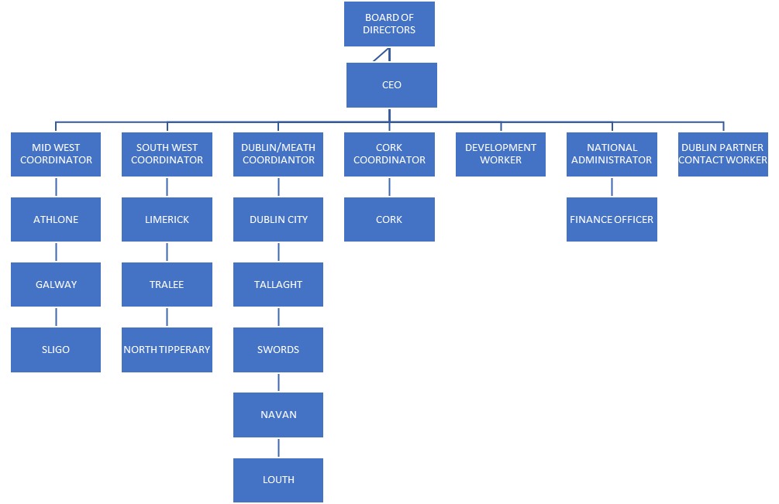

AIM OF TENDER

The aim of the review which we invite you to tender for is to complete an overall review of the Organisation. The review will take into account all models, structures, processes and existing best practices that support the development and sustainability of MOVE Ireland. It will incorporate all posts and their functions. This should include the way people’s resources are planned, managed, and improved. Meetings with MOVE Ireland personnel should take place remotely where possible but some travel to main sites will be required, i.e. Head office Ennis, Co. Clare.

The review to include:

- Review of the Organsational structure, including staff – permanent and short-term contracts, including contracts for services.

- Identify areas for improvement in present staff structures accompanied with job descriptions.

- Review Organisational workflow and core processes.

- Review current funding streams and to identify further funding opportunities.

- To identify opportunities for improving efficiency and resilience of the organisation and examine how it is preforming against its strategic objectives.

- To evaluate remuneration packages for employed staff.

Evaluate future key risks for the Organisation.

Budget
Budget: The budget for this project up to a maximum of €12000. Applicants are expected to accurately price the work involved.
Timeframe: Research work is expected to take place from 10th of April till 12th of May 2023. Final report to be submitted by 2nd June 2023.
Tenderers should note that Move Ireland is not obliged to accept the lowest or any tender.

Criteria for Assessment

Contract Award

Criteria | Maximum Score Available | Minimum Score Required
Relevant experience/track record of successfully delivered similar work | 40% | 16%
Quality of Plan | 30% | 12%
Cost | 20% | 8%
Structures, policies in place to ensure ethical and excellent data collection, management and protection in with Data Protection | 10% | 4%
Total Maximum Score Available | 100% | 40%

NOTE
- Bidders must achieve the above stated Minimum Score Required in all criteria outlined above.
- Only the top scoring Bidder that complies with the requirements set out in this Tender will be awarded contract, subject to the Bidder submitting a valid Tax Clearance Certificate and Certificate of Insurance.
- Bidders are reminded that MOVE Ireland reserves the right to cancel this competition at any stage prior to a formal contract being issue.

Explanation of Award Criteria

- Relevant Experience refers to the availability and relevant expertise of the staff member proposed to deliver the Services, particularly in terms of their experience and understating of the requirements of MOVE Ireland, including governance, evaluation and experience working in partnership with range of external agencies and larger statutory bodies. The availability of of proposed resources to deliver the service will also be assessed and confirmation of the ability of the supplier to provide the services for the duration of the project is required.
Relevant experience will be assessed using cover letter, CV( s) and references.
Bidders are also asked to submit an example of a previous evaluation completed.

- Quality of Plan refers to the quality of the proposed plan and method the bidder proposes to deliver the services. Quotations will be evaluated in terms of the extent to which they demonstrate their ability to meet the stated requirements of MOVE Ireland.

- Cost means the daily rate quoted inclusive of all fees, charges and expenses (if any) associated with the delivery of the Services and inclusive of VAT. MOVE Ireland will not be liable for any costs incurred by tenderers in the preparation of tenders or any associated work effort. It is the responsibility of the tenderer to ensure that they are fully aware and understand the requirements as laid down in the RFT. Tenderers will be responsible for any costs incurred by them in the event of them being required to attend clarification or other meetings.

REQUIRMENTS OF THE TENDER WINNER

The successful bidder will produce all the deliverables above on time as agreed with MOVE Ireland. They will liaise with the CEO and Board of Trustees on a regular basis to facilitate smooth delivery of the work.

They will complete a due diligence process and sign a Service Level Agreement (SLA) with MOVE Ireland which outlines their full responsibility to the Organisation. The SLA resulting form this process will run from the date of issue until the work is completed. The work includes reporting on expenditure, process and outcomes.

The successful bidder will also be required to have evidence of their own insurance and a valid tax clearance certificate.

The successful bidder will be required to comply with GDPR, MOVE Ireland’s data protection policy and adhere to best practice in relation to data processing and management.

FURTHER INFORMATION/QUESTIONS

All queries in relation to this tender must be submitted in writing to ewa@moveireland.ie no later than 1st of March 2023. Queries or requests for clarification received after this date will not be considered.

SUBMISSION DEADLINE

The deadline for receipt of submission is 24th of March. Tenders received after this date will not be considered. Shortlisted candidates may be called for interview.

TENDER REQUIREMENTS

Tenders should include the following:

- Cover letter highlighting previous relevant experience, particularly experience working with a range of Organisations and sectors including community organisations and statutory bodies. Bidders should include an example of previous evaluation report completed, similar to the type of work requested in this tender.
- Curriculum Vitae of person(s) applying, including two relevant referees (preferably one referee from one community sector organisation).
- A workplan, including clear milestones and deliverable, and proposed approach to carrying out the work, including a breakdown of days (maximum of two pages).
- A full budget breakdown including indication of hourly/daily rate, and all fees, charges and expenses.
- Where a group or consortium submits a proposal, a lead consultant must be nominated who shall be fully responsible for providing the services required by this brief.

BILLING AND PAYMENT

Payment for all services covered by this RFT will be paid within 30 days of presentation of appropriate invoices, the scheduling of which will be detailed in the contract agreed with the contractor. MOVE Ireland retains the right to withhold payment of fees where a service provider has failed to meet its contractual obligations in relation to the delivery of services to an acceptable level of quality.

CONTRACT PROVISIONS

After the contract has been awarded, MOVE Ireland reserves the right to negotiate with the preferred service provider, provisions, and specifications in addition to and/or different from those stipulated in this RFT and any tender. The preferred service provider will be expected to execute a Contract with MOVE Ireland. The Contract between MOVE Ireland and the preferred service provider may include the following:

- The preferred contractor’s Tender Proposal relating to this RFT
- Any mutually negotiated terms and conditions
- Any associated Service Level Agreement

CONFLICT OF INTERESTS AND REGISTERABLE INTERESTS

Any conflict of interest involving a tenderer must be fully disclosed to MOVE Ireland. Any registerable interest involving the tenderer and MOVE Ireland Board of Trustees or employees based on the terms advertised. This shall be without prejudice to the right of MOVE Ireland to cancel this competitive process and/or initiate a new contract award procedure at its sole discretion.

  - SCORING CRITERIA

Please cover the following points when submitting your proposal. The contract will be awarded from the qualifying tenders based on the most economically advantageous tender applying the following award criteria:

PART A | Score available
Understanding of our requirements | 12.5%
Please outline how the requirements detailed in Section A: Points 3  & 4 will be met. | 30%
Please outline the support being offered to ensure  successful implementation. | 15%
Please outline your implementation plan with realistic deadlines to  meet the deadlines listed in Section A page 1. | 7.5%
PART B | Score Available
Please outline in detail the full costs involved in delivering on this project. Please detail costs for developing the platform and providing training and support. (support hourly rates, fixed price, time, and materials, etc.), plus VAT if applicable.  Are there any other costs that would arise? Please detail. | 35%

PART A: Qualitative Requirements

Tenderers must fully address each qualitative requirement set out in Part A. Tenderers must provide a detailed description of how each requirement will be met. A statement that they will be met is not sufficient and may result in elimination from the tender competition.
Whilst every endeavour has been made to provide tenderers with an accurate description of the requirements, tenderers should form their own conclusions about the methods and resources needed to meet those requirements. Move Ireland cannot accept responsibility
for tenderers’ assessment of the requirement.

To ensure consistency and equity the evaluation panel will assign scores for quality of response to the Qualitative Requirements using the scoring definitions below:

Score | Indicator
0 | Failed to address the requirement.
1 | A response with serious reservations. Limited detail of the methodology to be applied. High risk that the proposed approach will not be acceptable.
2 | A response with reservations. Lacks convincing detail of the methodology to be applied. Medium risk that the proposed approach will not be successful.
3 | Meets Requirements. The response generally meets the Client’s requirements but lacks sufficient detail to warrant a higher mark.
4 | A good response that meets the Client’s requirements with good supporting evidence.

SUBMISSION OF TENDERS
Tenders are to be submitted by e-mail and must include a signed Cover Letter referring to the Tender. While supporting documents may be provided as addendum to the main
tender, the format of the response must be followed and a single clearly labelled “Move Ireland RFT” must be provided, with clear and unambiguous references to any supplied addendum material if such is provided. Any addenda to the main tender must be clearly labelled and include clear identification of the tenderer. The identity and contact details of the respondent should be clearly provided within the tender.

Late Responses
It is the responsibility of respondents to ensure that the tender document is received on time. Under no circumstances can Move Ireland consider tenders that are received late. Tenders delivered after the above deadlines will not be opened.
Tenderers must not make assumptions that Move Ireland has prior knowledge of their organisation or their service provision. Tenderers will only be evaluated on the information provided in their response.
Following the scoring of tenders under the criteria detailed in SECTION B the highest scoring tenderers may be required to provide additional details, to verify or clarify information supplied, to make formal presentations of their proposals.
Move Ireland’s decision in awarding a contract(s) will be final. All tenderers will be notified of the outcome of their tender following the completion of the tender evaluation and subsequent clarifications (if any). Potential outcomes can be:
- A letter of intent to award

- A letter of regret

- Notification of cancellation/postponement

Awards to other suppliers
If for any reason it is not possible to award the contract to a single supplier designated as the successful tenderer emerging from this competitive process, or if having awarded the contract, Move Ireland considers that the successful tenderer has not met its obligations, Move Ireland reserves the right to award the contract to the next highest scoring tenderer

based on the terms advertised. This shall be without prejudice to the right of Move Ireland to cancel this competitive process and/or initiate a new contract award procedure at its sole discretion.

CONTRACT TERMS AND CONDITIONS

Billing and payment
Payment for all services covered by this RFT will be paid within 30 days of presentation of appropriate invoices, the scheduling of which will be detailed in the contract agreed with the contractor. Move Ireland retains the right to withhold payment of fees where a service provider has failed to meet its contractual obligations in relation to the delivery of services to an acceptable level of quality.

Contract Provisions
After the contract has been awarded, Move Ireland reserves the right to negotiate with the preferred service provider(s), provisions, and specifications in addition to and/or different from those stipulated in this RFT and any tender. The preferred service provider(s) will be expected to execute a Contract(s) with Move Ireland. The Contract between Move Ireland and the preferred service provider may include the following:
    - The preferred contractor’s Tender Proposal relating to his RFT

    - Any mutually negotiated terms and conditions

    - Any associated Service Level Agreement

Costs Incurred by Contractors
Move Ireland will not be liable for any costs incurred by tenderers in the preparation of tenders or any associated work effort. It is the responsibility of the tenderer to ensure that they are fully aware and understand the requirements as laid down in the RFT. Tenderers will be responsible for any costs incurred by them in the event of them being required to attend clarification or other meetings.

Validity of Tender
The tender should be valid for 90 days after the closing date for receipt of tenders.

Conflict of Interests & Registerable Interests
Any conflict of interest involving a tenderer must be fully disclosed to Move Ireland. Any registerable interest involving the tenderer and Move Ireland Board Members or employees of Move Ireland or their relatives must be fully disclosed in the tender or should be communicated to the Board immediately upon such information becoming known to the tenderer, in the event of this information only coming to their notice after the submission of a bid and prior to the signing of a contract. Failure to disclose a conflict of interest may disqualify a tenderer, depending on when the conflict of interest comes to light.

GENERAL

Tenderers should confirm willingness to comply with Move Ireland’s standard contract terms and conditions which will be supplied upon agreement and award of contract.

Tenderers should also supply any other information or proposed add-ons that is specifically relevant to this RFT.

Signed tenderer’s declaration to be provided as per Appendix 1

Appendix 1: Tenderer’s Declaration

This declaration must be submitted by all Tenderers. Where the Tenderer is a company, partnership or consortia, declaration must be completed by a duly authorised representative.

Name of Tenderer:

Address:

I solemnly declare that I have been duly authorised to make this declaration by the Tenderer and I hereby certify as follows:

The Tenderer is not bankrupt or being wound up, its affairs are not being administered by a court, it has not entered into an arrangement with its creditors, it has not suspended its business activities, nor is it in any analogous situation arising from a similar procedure under national laws and regulations.

The Tenderer is not the subject of proceedings for a declaration of bankruptcy, for an order for compulsory winding up or administration by the court or for an arrangement with creditors or of any other similar proceedings under national laws and regulations.

The Tenderer has fulfilled its obligations relating to the payment of taxes or social security contributions in its country of establishment or any other State in which the Tenderer is located and is able to provide a valid tax clearance certificate when requested.

The Tenderer has not been guilty of serious misrepresentation or omission in providing information to a public buying agency.

The Tenderer (or any of its directors or partners) has not been convicted of fraud, money laundering, corruption, or of being a member of a criminal organisation.

The Tenderer has Professional Indemnity and Public Liability insurances to the levels required.

I further declare that the information provided above is accurate and complete to the best of my knowledge and belief. I understand that the provision of inaccurate or misleading information in this declaration may lead to my company/partnership being excluded from participation in this or future Tenders.

This declaration is made for the benefit of Move Ireland.

NAME (PRINT): POSITION/TITLE: TELEPHONE NO.: SIGNATURE: DATE:

Appendix 2
Move Ireland may verify the reference provided by contacting the referee directly. Your organisation must therefore ensure that the referee has given prior consent to this before submitting the required reference.

Referee’s Organisation:
Name of Referee:
Job Title:
Address:
Telephone Number(s):
Email Address:
Date of Reference:
Project Delivery Dates:

Referee’s Organisation:
Name of Referee:
Job Title:
Address:
Telephone Number(s):
Email Address:
Date of Reference:
Project Delivery Dates:

