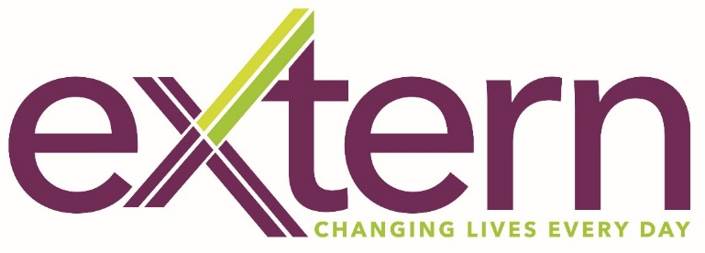

Extern Ireland Board Appointments

As one of the leading charities on the island of Ireland, Extern changes the lives of over 25,000 people every year. Operating since 1978, we employ over 650 staff and are operational in 27 counties across the island.

We are now seeking to appoint Extern Ireland Board Directors with the skills to positively contribute to our mission of creating opportunities and providing supports to enable everyone to meaningfully participate in society.

We believe another chance can change a life, and this ethos has led Extern to develop an unparalleled range of supports for individuals, children, and families living with issues including family breakdown, homelessness, problem gambling, problem drug and alcohol use and mental health issues. We also support refugees, the Traveller community and people living with an offending past to change their lives.

If you feel passionately about any of these areas, have a background or experience in governance at board or senior management level, and believe you could make a difference to the lives of the many people we support, then we would love to hear from you.

Extern Ireland Board Directors must reside in the Republic of Ireland and are not remunerated, but reasonable travel and subsistence allowances are paid. Openness and transparency are key requirements so all potential conflicts of interest must be declared on application.

Please express your interest confidentially by sending your résumé via email to ruth.thompson@extern.org. The closing date for expressions of interest is Friday 4 June 2021 at 5pm.

