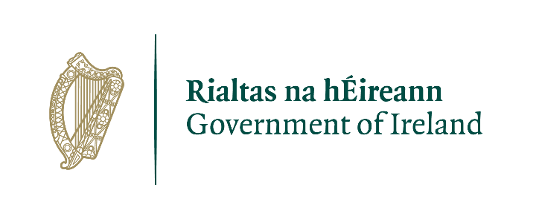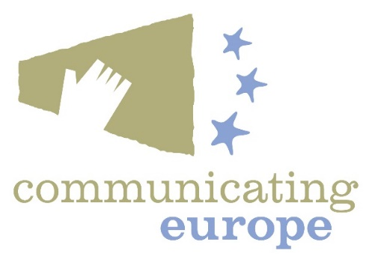

Communicating Europe Initiative 2021

Applications are invited for funding under the Department of Foreign Affairs Communicating Europe Initiative (CEI) from voluntary organisations, educational bodies and civil society groups and bodies.
Purpose of funding

Projects should deepen public awareness of the role that the European Union plays in our daily lives, and improve the quality and accessibility of public information on European issues, at local, regional or national level.
Projects should communicate European issues, the role of the European Union and Ireland’s place in Europe.
Previous projects funded have included local media projects and competitions, school initiatives and interactions, employment opportunities in EU Institutions and EU-related Citizens’ Dialogues. Projects have promoted themes on the role of women and young people in the EU, climate action and the importance of diversity in Ireland to our relationship with the EU.
For 2021, projects that reach a wide range of audiences and encourage a high level of meaningful interaction with contemporary EU issues and policies are welcome. Media and radio projects are particularly encouraged.
Further details on the Communicating Europe Initiative can be found at www.dfa.ie

Qualification and evaluation criteria
Applicants will have to confirm compliance with the conditions of the scheme on funding and timescale for delivery.

The evaluation criteria will include:
- the quality and relevance of the proposal;
- the likely impact of the project relative to the size of the grant sought.
- the nature of promotional activities planned.

Projects must be carried out before the end of 2021.

Proposals should take account of Government guidelines on responding to Covid-19, available at www.gov.ie
Please note: Applicants who have received CEI funding in previous years must identify how their planned project under the 2021 CEI scheme builds on, adds value to, or is separate from previously funded projects.

Budget and grants available
The allocation for the CEI in 2021 is €100,000. While decisions on the number and level of grant will be dependent on the number and range of proposals received, it is envisaged that the maximum individual grant awarded will be €15,000.

Application process
Please return your completed application via email to cei@dfa.ie.

You can also contact us via email at cei@dfa.ie or laura.guild@dfa.ie if you have any queries.

The closing date for funding applications is noon on Friday 9th April 2021.

Applicants will be notified of funding decisions in late April.

Canvassing will disqualify.

Tá leagan Gaeilge den fhoirm seo ar fáil ach é a iarraidh.

Communicating Europe Initiative
EU Institutions and Coordination Unit
Department of Foreign Affairs
22 Clare Street
Dublin 2
March 2021

Communicating Europe Initiative 2021
Application Form

Contact and project details
- Title of Project:

- Name of Organisation:

- Address of Organisation:

- Website / Social Media:

- Project Manager name, position, email and telephone number:

- Funding requested:

Your Organisation
- Information about your organisation, including its aims, membership, and governance.

- Has your organisation previously organised an event or project with a European theme?

- If so, did it receive funding from the Communicating Europe Initiative?

Project Implementation

- Please describe the proposed project in no more than 500 words, to include:

Project type/purpose and relevant information (For publication or website-based projects, please give relevant titles and web address and circulation statistics. For event-based projects, please state venue, indicative date and anticipated attendance).

Who the project is aimed at/target audience

The timetable for the project

Promotional plans

The goals and envisaged outcomes of the project and how achievement will be measured/demonstrated

How the project meets the criteria for funding

- Other information which you consider relevant (more extensive information can be attached if required).

Financial information

- How much funding is being sought from the Communicating Europe Initiative? The maximum grant available is €15,000.

- Total cost of the project and other sources of funding, where applicable.

- Itemise all costs for the proposed project. Note that additional documentation may be sought by the Department of Foreign Affairs.

- Declaration
I hereby declare that the particulars given in this application are correct.
I have read the attached terms and conditions of the scheme, and confirm that the proposal complies with the conditions of the scheme as to funding and timescale for delivery.
Signature:
Name (in block capitals):
Date:

Communicating Europe Initiative 2021

Standard terms and conditions

- The grant should only be used in support of the project as set out in the funding application. Any proposed substantial amendment to the programme or to its timing should be notified in advance to the Department of Foreign Affairs and agreed in writing.

- Financial support is given on the understanding that the grant is properly administered, that activities funded under the budget shall be recorded fully and accurately and that funds shall be assigned to the project only by persons whom you have empowered to do so.

- As the Department cannot fund projects retrospectively, the work to be funded must begin after the Department’s offer is accepted. As the Department cannot roll over funding from one year to the next, all projects must be completed by 8 December 2021.

- The Department does not specify the number of projects to be funded or the individual grant amounts. €100,000 will be available for CEI projects with the maximum grant amount payable of €15,000. The amount granted may be lower than the amount sought and, in this event, applicants should have contingency plans to enable the project to proceed.

- The assistance of the Communicating Europe Initiative and the Department of Foreign Affairs must be acknowledged in all publicity relating to the project. Government of Ireland and Communicating Europe Logos will be provided for downloading.

Reporting requirements
- Grantees are required to submit a concise report to the Department of Foreign Affairs, not later than one month after completion of the project, describing the activities undertaken. For any project which concludes late in the year, an interim report may be submitted not later than 8 December 2021, followed by the final report within one month of completion of the project.

- The report should include the following:

- Description of the activity/event undertaken and the extent to which planned outcomes were achieved;
- An assessment of the impact of the activity/event on public awareness and understanding of the European Union in Ireland (including statistics on attendance, reach to target audience, promotional activities undertaken etc.)
- any other information which you consider relevant or feedback on the project generally.

- For event-based projects, digital links and media files (pictures, video, website links etc.) should be provided for use on the Department’s website or for other publicity purposes.

Payment arrangements
- For any grant up to and including €5,000 the full amount will be paid up-front. For larger grants, 75% of the grant amount will be paid up-front with the balance payable upon submission of the final report. All claims for payment must be made not later than 8 December 2021. It will not be possible to make payments for any claims submitted after that date.

- Any part of the grant paid which has not been spent must be refunded to the Department of Foreign Affairs within one month of completion of the project. The Department reserves the right to charge interest, at ECB base rate, on any outstanding monies from the date of project completion.

Accounting requirements
- Grantees are required to submit a financial statement detailing all expenditure and originals of all invoices, vouchers and supporting documentation, to the Department of Foreign Affairs, not later than three months after completion of the project.

Communicating Europe Initiative
EU Institutions and Coordination Unit
Department of Foreign Affairs
22 Clare Street
Dublin 2
March 2021

