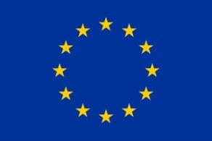

Research Leaders 2025 Call 2
Host Supervisor’s Profile

This project has received funding from the European Union’s Horizon 2020 research and innovation programme under the Marie Skłodowska-Curie
grant agreement No 754380
Host Supervisor’s Profile for Research Leaders 2025 Fellowship Programme

Host Supervisor Name:
Host Supervisor Organisation Name:
Host Supervisor Department:
Host Supervisor Address:
Host Supervisor Contact Details:
Link to Host Supervisor Webpage:
LinkedIn
ResearchGate
GoogleScholar
ResearcherID
OrcID
or any other relevant profile:
Twitter:
Max. 6 keywords to describe research area of interest for RL2025 application:
Research Group Website if available:
Brief Description of Research Group:
Research area of interest for RL2025 application:
Experience of Supervision:

